**LIFELINK**

**PROJECT THESIS SUBMITTED**

**TO**

**AWH ENGINEERING COLLEGE KUTTIKATTOOR, KOZHIKODE-8**

### IN PARTIAL FULFILMENT

**OF THE REQUIREMENTS FOR THE AWARD OF THE DEGREE**

**OF**

**Master Of Computer Applications**

**BY SANIGA M K**

### DEPARTMENT OF COMPUTER APPLICATIONS AWH ENGINEERING COLLEGE KUTTIKKATTOOR,

**KOZIKODE**

**MAY2024**

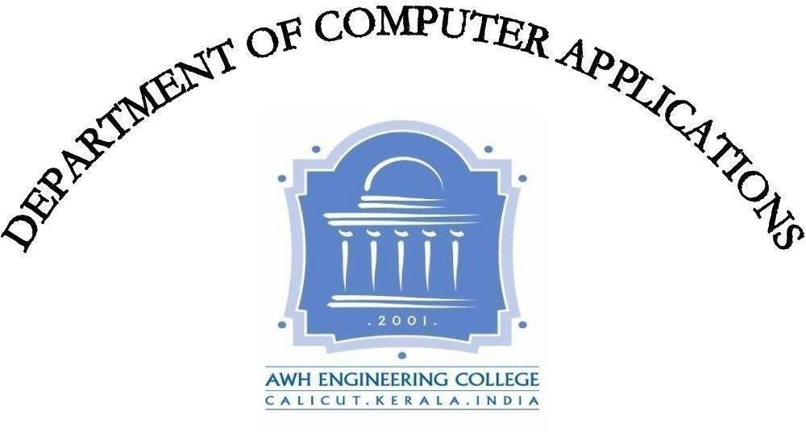

**AWH ENGINEERING COLLEGE**

KOZHIKODE

#### CERTIFICATE

*This is to certify that this thesis entitled* ***“LifeLink”*** *submitted herewith is an authentic record of the thesis work done by* ***SANIGA MK (AWH22MCA-2034)*** *under our guidance in partial fulfillment of the requirements for the award of* ***Master of Computer Applications*** *from APJ Abdul Kalam Technological University during the academic year 2024.*

#### Mrs.Sruti Sudevan Mrs.Sruti Sudevan

Assistant Professor Assistant Professor

Dept. of Computer Applications Dept. of Computer Applications Head of the department Project guide

**External Examiner Internal Examiner**

### ACKNOWLEDGEMENT

I express my sincere gratitude to our beloved principal **Dr.Sabeena M V** for providing me an opportunity with the required facilities for doing this project. I express my hearty thanks to **Mrs.Sruti Sudevan**, Head of the Department of Computer Applications for her guidance. I am thankful to all other staff of the MCA department for their encouragement, timely guidance, valuable suggestions and inspiring ideas given throughout this project. I am grateful to my friends for the way they have cooperated, expected me to achieve success and have always stirred my ambition to do the best. Above all, I am grateful to the almighty, who has showered His blessings on me throughout my life and throughout the project.

**SANIGA M K**

### ABSTRACT

This “LifeLink” is a robust platform designed to enhance the efficiency of blood and organ donation processes by establishing seamless collaboration among hospitals, colleges, and blood and organ donors, users. Lifelink is a complete solution that helps make donation processes smoother and improves healthcare results. By facilitating transparent and efficient communication channels, Lifelink empowers hospitals to manage blood and organ donation requests effortlessly, thereby optimizing the supply chain and ensuring timely access to critical resources. Blood donors use Lifelink's easy-to-understand website to handle donation requests they receive. This makes it easier to communicate and speed up the donation process. Likewise, organ donors can quickly sign up, check, and agree to donation requests from hospitals, making organ transplants happen faster. Lifelink helps colleges and hospitals talk easily, so colleges can quickly ask for blood donations. The web application aims to overcome challenges, encourage community involvement, and promote a culture of giving within the healthcare ecosystem. This collaborative network create a more accessible and responsive donation framework, ultimately contributing to improved healthcare services and community well-being.

**CONTENTS**

Page No

1. INTRODUCTION 1
2. SYSTEM ANALYSIS 3
   1. Existing System 4
   2. Proposed System 4
   3. Module Description 5
   4. Sprint 7
   5. User stories 11
3. FEASIBILITY STUDY 12
   1. Economical Feasibility 13
   2. Technical Feasibility 13
   3. Operational Feasibility 13
   4. Behavioral Feasibility 14
   5. Software Feasibility 14
   6. Hardware Feasibility 14
4. SOFTWARE ENGINEERING PARADIGM 15
   1. Agile Model 16
   2. Scrum 17
5. SYSTEM REQUIREMENTS SPECIFICATIONS 20
   1. Software Requirements 21
   2. Hardware Requirements 21
6. SYSTEM DESIGN 22
   1. Mongo DB 23
   2. Collection 23
   3. UML Design 25
   4. Use case Diagram 26
   5. Scenario 28
   6. Sequential Diagram 30
7. SYSTEM DEVELOPMENT 37
   1. Coding 38
8. SYSTEM TESTING AND IMPLEMENTATION 40
   1. Types of Testing 41
9. SYSTEM MAINTENANCE 44
10. FUTURE ENHANCEMENT 46
11. CONCLUSION 48
12. APPENDIX 50

13. BIBLIOGRAPHY 79

# INTRODUCTION

### 1.INTRODUCTION

Introducing "LifeLink" a smart system that makes donating blood and organs easier and faster. It helps hospitals, colleges, and blood and organ donors work together smoothly and ensuring seamless collaboration in meeting the critical need for blood and organ donations. The lack of availability of blood and organs at the time of need is one of the major health problems faced by the people in the society, so this web application to overcome these limitation. The LifeLink web application envision a process of giving and receiving blood and organs. The web system is all about solving donation challenges, getting communities involved, and spreading a culture of giving in healthcare. With LifeLink, blood donors and organ donors can quickly register and donate blood and organ, ensuring no delay in life-saving contributions. Users experience a user-friendly interface, allowing them to request blood promptly without any hassle or time lag, ensuring efficient and timely responses to critical medical needs.

# SYSTEM ANALYSIS

### 2.SYSTEM ANALYSIS

#### Existing system

The existing system may lack the seamless collaboration and bidirectional communication proposed by LifeLink. Current processes for blood and organ donation may be less efficient, with potential challenges in information management and accessibility. The user interfaces for hospitals, colleges, and blood and organ donors might not be as user-friendly, and there may be gaps in ensuring the transparent protection of sensitive information. The collaborative network introduced by LifeLink aims to address these limitations, creating a more accessible and responsive donation framework to contribute to improved healthcare services and community well-being.

The existing system has several disadvantages:

* + - Lack of seamless collaboration and bidirectional communication.
    - Non-user-friendly interfaces for hospitals, colleges, and donors.

#### Proposed system

The "LifeLink" platform proposes a robust system to enhance blood and organ donation processes by facilitating seamless collaboration among hospitals, colleges, and donors. Key features include bidirectional communication between hospitals and colleges for blood donation, user-friendly interfaces for all stakeholders, and a transparent system to protect sensitive information. The project aims to overcome challenges, encourage community involvement, and foster a culture of giving within the healthcare ecosystem.

The proposed system has several advantages:

* + - Enables bidirectional communication between hospitals to hospital and colleges, blood donors for blood donation.
    - Provides user-friendly interfaces for all stakeholders involved
    - Overcomes challenges in the organ and blood donation process.

#### Module Description

This project has 6 modules:

##### Admin

* + - Login
    - View & manage hospital
    - View & manage users
    - View & manage blood donors
    - View & manage organ donors
    - Add categories
    - View donations
    - View & manage college

##### Hospital:

* + - Register
    - Login
    - View & manage blood donors request
    - View organ donors registered under hospital and send request
    - View organ request from hospital & send request to organ donors
    - Send organ request to hospital
    - Manage blood request from hospital
    - Send blood request
    - Manage blood request from user
    - Manage college request
    - Send blood request to college
    - View blood donation history
    - View organ donation history
    - Profile edit

##### College:

* + - Register
    - Login
    - Profile edit
    - View and manage hospital request
    - Send request to hospital
    - View history

**Blood donors:**

* + - Register
    - Login
    - Profile edit
    - View & manage user request
    - Send request to hospital for blood donation
    - View history

**Organ donors:**

* Register
* Login using nominee credentials and organ donor credentials
* View & accept hospital organ donation request
* Update donor details

**User:**

* + - Register
    - Login
    - Send blood request
    - View history
    - Profile edit

#### Sprint

#### Sprint 1

|  |  |  |  |  |  |
| --- | --- | --- | --- | --- | --- |
| Module | Task | Hours for completion | Expected date of completion | Actual date of completion | Reason for Deviation |
| Admin/Hospital/Organ donor/User/ college/blood donor | Login | 8 hours | 29/01/2024 | 29/01/2024 | - |
| Admin | Manage hospital | 7 hours | 30/01/2024 | 30/01/2024 | - |
| Manage blood donor | 7 hours | 31/01/2024 | 31/01/2024 | - |
| Manage organ donor | 8 hours | 01/02/2024 | 01/02/2024 | - |
| Manage user | 7 hours | 02/02/2024 | 02/02/2024 | - |
| Manage college | 7 hours | 03/02/2024 | 03/02/2024 | - |
| View hospital blood donation | 7 hours | 05/02/2024 | 05/02/2024 | - |
| View hospital organ donation | 8 hours | 06/02/2024 | 06/02/2024 | - |
| View blood donor donation | 7 hours | 07/02/2024 | 07/02/2024 | - |
| View college donation | 7 hours | 08/02/2024 | 08/02/2024 | - |
| Add categories | 7 hours | 09/02/2024 | 09/02/2024 | - |

#### Sprint 2

|  |  |  |  |  |  |
| --- | --- | --- | --- | --- | --- |
| Module | Task | Hours for completion | Expected date of completion | Actual date of completion | Reason for Deviation |
| Blood donor  sa | Send request for donation | 5 hours | 12/02/2024 | 12/02/2024 | - |
| View hospitals | 5 hours | 13/02/2024 | 13/02/2024 | - |
| View send request | 5 hours | 14/02/2024 | 14/02/2024 | - |
| View user request | 6 hours | 15/02/2024 | 15/02/2024 | - |
| View accepted request | 6 hours | 16/02/2024 | 16/02/2024 | - |
| Registration | 5 hours | 17/02/2024 | 17/02/2024 | - |
| Manage profile | 6 hours | 19/02/2024 | 19/02/2024 | - |
| Validation | 5 hours | 20/02/2024 | 20/02/2024 | - |
| Session | 6 hours | 21/02/2024 | 21/02/2024 | - |
| Organ donor  sa  sa  sa | View hospital request | 5 hours | 22/02/2024 | 22/02/2024 | - |
| Manage profile | 6 hours | 23/02/2024 | 23/02/2024 | - |
| Nominee can update profile | 5 hours | 26/02/2024 | 26/02/204 | - |
| Registration | 5 hours | 27/02/2024 | 27/02/204 | - |
| Nominie login | 5 hours | 28/02/2024 | 28/02/204 | - |
| Validation | 5 hours | 1/03/2024 | 1/03/2024 | - |

#### 

#### Sprint 3

|  |  |  |  |  |  |
| --- | --- | --- | --- | --- | --- |
| Module | Task | Hours for completion | Expected date of completion | Actual date of completion | Reason for Deviation |
| Hospital | Registration | 5 hours | 02/03/2024 | 02/03/2024 | - |
| View and accept blood donors request | 5 hours | 06/03/2024 | 06/03/2024 | - |
| View organ donors and send request | 5 hours | 11/03/2024 | 11/03/2024 | - |
| View hospital blood request | 5 hours | 13/03/2024 | 13/03/2024 | - |
| View hospital organ request | 5 hours | 15/03/2024 | 15/03/2024 | - |
| Send blood request | 5 hours | 16/03/2024 | 16/03/2024 | - |
| Send organ request | 5 hours | 18/03/2024 | 18/03/2024 | - |
| Send blood request to college | 3 hours | 20/03/2024 | 20/03/2024 | - |
| View user request | 3 hours | 22/03/2024 | 22/03/2024 | - |
| View college request | 5 hours | 23/03/2024 | 23/03/2024 | - |
| View donor history | 5 hours | 25/03/2024 | 25/03/2024 | - |
| View Hospital blood history | 5 hours | 26/03/2024 | 26/03/2024 | - |
|  | View college donation history | 5 hours | 27/3/2024 | 27/3/2024 | - |
|  | View send hospital organ request | 5 hours | 28/3/2024 | 28/3/2024 | - |
|  | View send request to organ donors | 5 hours | 29/3/2024 | 29/3/2024 | - |
|  | Update profile | 5 hours | 30/3/2024 | 30/3/2024 | - |
|  | Validation | 4 hours | 01/4/2024 | 01/3/2024 | - |

#### Sprint 4

|  |  |  |  |  |  |
| --- | --- | --- | --- | --- | --- |
| Module | Task | Hours for completion | Expected date of completion | Actual date of completion | Reason for Deviation |
| College  sa | View hospital request | 7 hours | 02/04/2024 | 02/04/2024 | - |
| Send request to hospital | 7 hours | 03/04/2024 | 03/04/2024 | - |
| View hospitals | 6 hours | 05/04/2024 | 05/04/2024 | - |
| Manage profile | 6 hours | 06/04/2024 | 06/04/2024 | - |
| View history | 6 hours | 08/04/2024 | 08/04/2024 | - |
| Registration | 6 hours | 09/04/2024 | 09/04/2024 | - |
| Validation | 6 hours | 11/04/2024 | 11/04/2024 | - |
| Session | 6 hours | 12/04/2024 | 12/04/2024 | - |
| User  sa  sa  sa | Send request for blood | 6 hours | 15/04/2024 | 15/04/2024 | - |
| View history | 6 hours | 17/04/2024 | 17/04/2024 | - |
| Update the profile | 6 hours | 18/04/2024 | 18/04/2024 | - |
| Registration | 6 hours | 19/04/2024 | 19/04/2024 | - |
| Validation | 6 hours | 20/04/2024 | 20/04/2024 | - |

#### User Stories

LifeLink is a web application which consist of 6 modules as Admin, Blood donor, Organ donor, Hospital, College and User. Admin will be responsible for managing the Blood donor , Organ donor, Hospital, College and User. Admin will be able to view the all blood and organ donations of college , blood donors and hospital, Add the category of organ after death and before death

Blood donors should be able to register and login to send blood donation request to hospital, Blood donors will be able to view and manage the users request for blood, view the blood donation history. Blood donors will also able to view the profile and update it.

Organ donors should be able to register and login to view and accept the hospital request and organ donor can update the profile also the nominie can login and update the profile.

Hospital should be able to register and login, can view and manage the blood donors request for blood donation with blood donor preference. Hospital will be able to add organ donors and update the organ donors, manage request for blood and organ donation of other hospitals, assign organ donor to the organ request, They will be able to send request for organ and blood to hospital, request for blood to college. They manage request from college for blood donation and also manage request from the user for blood. They can view the blood donation history of blood donors, view the send and received blood donation history of hospitals and colleges and view the send and received organ donation history. Hospital will also able to view the profile and update it.

Colleges should be able to register and login to send a request to hospital for blood donation, they can manage the request from the hospitals for blood, view the history of requests. College will also able to view the profile and update it.

User should be able to register and login to send a request for blood ,they view the donation history. User will be able to view the profile and update it.

# FEASIBILITY STUDY

### 3.FEASIBILITY STUDY

#### An analysis of the ability to complete a project successfully, taking into account legal, economic, technological, scheduling, and other factors is considered a feasibility study. Rather than just diving into a project and hoping for the best, feasibility study allows project managers to investigate the possible negative and positive outcomes of a project before investing too much money and time.

#### Economical Feasibility

The economic analysis is done to determine the benefits and savings that are expected from the candidate system and compare them with costs. Thus, coming to a conclusion on whether the system is economically feasible or not. This system is cost effective as well as time effective, thereby making it economically feasible. This study presents tangible and intangible benefits from the project by comparing the developments and operational costs.The technique of cost benefit analysis is often used as a basis for assessing economic feasibility.

#### Technical Feasibility

The technical requirements for the system is economic and it does not use any other additional hardware. This application is developed using MERN stack, whose development kit are easily available and free of cost, thud making our system technically feasible.

#### Operational Feasibility

#### Operational feasibility is determined by how well the system meets requirements. Since the system is user-friendly and minimizes manual work, it is considered operationally feasible. The user-friendly nature of the system reduces the workload for all entities involved. The streamlined user experience enhances adoption rates among stakeholders, fostering widespread acceptance and utilization of the system. By automating tasks and simplifying processes, the system optimizes efficiency and productivity, further bolstering its operational feasibility.

#### Behavioural Feasibility

#### This analysis involves how it will work when it is installed and the assessment of the political and managerial environment in which it is implemented. People are inherently resistant to change and computer have been known to facilitate change. The new proposed system is very much useful to the users and therefore it will accept a broad audience

#### 3.5 Software Feasibility

Even though this application is developed in a very high software environment, it is also supported by many other environments with minimal changes. The system is fully feasible to be executed on any kind of operating systems and browsers.

#### Hardware Feasibility

Software can be developed with the existing resources. But the existing resources may or may not be used to produce hardware. If no hardware is newly bought for a project, then software is said to achieve hardware feasibility. The system is hardware-wise feasible because it needs absolutely no new hardware.

**SOFTWARE ENGINEERING PARADIGM**

### 4.SOFTWARE ENGINEERING PARADIGM

#### The software engineering paradigm which is also referred to as a software process model or Software Development Life Cycle (SDLC) model is the development strategy that encompasses the process, methods and tools. SDLC describes the period of time that starts with the software system being conceptualized.

#### Agile model

Agile SDLC model is a combination of iterative and incremental process models with focus on process adaptability and customer satisfaction by rapid delivery of working software product. Agile Methods break the product into small incremental builds. These builds are provided in iterations. Each iteration typically lasts from about one to three weeks. At the end of the iteration, a working product is displayed to the customer and important stakeholders. Agile Methods break the product into small incremental builds. These builds are provided in iterations. Each iteration typically lasts from about one to three weeks.

At the end of the iteration, a working product is displayed to the customer and important stakeholders. Agile model believes that every project needs to be handled differently and the existing methods need to be tailored to best suit the project requirements. In Agile, the tasks are divided to time boxes (small time frames) to deliver specific features for a release.

Agile software development is an umbrella term for a set of frameworks and practices based on the values and principles expressed in the Manifesto for Agile Software Development and the 12 Principles behind it. When user approach software development in a particular manner, it’s generally good to live by these values and principles and use them to help figure out the right things to do given users particular context. One thing that separates Agile from other approaches to software development is the focus on the people doing the work and how they work together. Solutions evolve through collaboration between self-organizing cross-functional teams utilizing the appropriate practices for their context.

In Agile software development, fostering a culture of continuous improvement is paramount. Teams embrace change and adaptability, valuing feedback loops and frequent iterations to deliver high-quality software that meets evolving customer needs. Transparency and open communication are encouraged, allowing for early identification and resolution of issues. By prioritizing individuals and interactions over processes and tools, Agile teams harness the collective expertise and creativity of team members to drive innovation and deliver value effectively. Embracing Agile principles empowers teams to navigate complexity with agility, delivering software that not only meets expectations but also exceeds them, driving success in today's dynamic and competitive landscape.

#### Scrum

Scrum is an agile framework for managing knowledge work, with an emphasis on software development. It is designed for teams of three to nine members, who break their work into actions that can be completed within time boxed iterations, called "sprints", no longer than one month and most commonly two weeks, then track progress and re-plan in 15-minute stand-up meetings, called daily scrums.

Scrum is an iterative and incremental framework for managing product development. It defines "a flexible, holistic product development strategy where a development team works as a unit to reach a common goal", challenges assumptions of the "traditional, sequential approach to enables teams to product development, and enables teams to selforganize by encouraging physical co-location or close online collaboration of all team members, as well as daily face-to-face communication among all team members and disciplines involved.

Scrum is a framework that helps teams work together. Much like a rugby team (where it gets its name) training for the big game, scrum encourages teams to learn through experiences, self-organize while working on a problem, and reflect on their wins and losses to continuously improve.

While the scrum is talking about is most frequently used by software de-

velopment teams, its principles and lessons can be applied to all kinds of teamwork. This is one of the reasons scrum is so popular. Often thought of as an agile project management framework, scrum describe a set of meetings, tools, and roles that work

in concert to help teams structure and manage their work. Scrum is the most common agile framework, and the one most people start with. Agile practices on the other hand, are techniques applied during phases of the software development lifecycle. Planning poker for example, is a collaborative estimation practice designed to encourage team members to share their understanding of what done means. The process is quite fun, and has proven to help foster teamwork and better estimates. Continuous integration (also known as ci) is a common agile engineering practice where code changes are integrated into the main branch frequently. An automated build verifies changes, leading to a reduction in integration debt and a continually shippable main branch. These practices, like all agile practices, carry the agile label, because they are consistent with the principles in the agile manifesto.

In the project management, scrum, sometimes written scrum or scrum, is a framework for developing, delivering, and sustaining products in a complex environment, with an initial emphasis on software development, although it has been used in other fields including research, sales, marketing and advanced technologies. It is designed for teams of ten or fewer members, who break their work into goals that can be completed within time-boxed iterations, called sprints, no longer than one month and most commonly two weeks. The scrum team assess progress in time-boxed daily meetings of 15 minutes or less, called daily scrums (a form of stand-up meeting). At the end of the sprint, the team holds two further meetings: the sprint review which demonstrates the work done to stakeholders to elicit feedback, and sprint retrospective which enables the team to reflect and improve.

A key principle of scrum is the dual recognition that customers will change their minds about what they want or need and that there will be unpredictable challenges-for which a predictive or planned approach is not suited. As such, scrum adopts an evidence based empirical approach accepting that the problem cannot be fully understood or defined up front, and instead focusing on how to maximize the team's ability to deliver quickly, to respond to emerging requirements, and to adapt to evolving technologies and changes in market conditions. Many of the terms used in scrum (e.g., scrum master) are typically written with leading capitals (e.g., scrum master) or as conjoint words written in camel case (e.g., scrum master). To maintain an encyclopaedic tone, however, this

article uses normal sentence case for these terms-unless they are recognized marks.

This is occasionally seen written in all -capitals, as scrum. The word is not an acronym, so this is not correct; however, it likely arose due to an early paper by ken schwaber which capitalized scrum in its title. While the trademark on the term scrum itself has been allowed to lapse, so that it is deemed as owned by the wider community rather than an individual, the leading capital is retained-except when used with other words. Although the trademark for "scrum" has lapsed, signifying communal ownership rather than individual ownership, the convention of initial capitalization is maintained, except when it is combined with other words. This convention serves to uphold consistency and clarity within the discourse surrounding agile methodologies, ensuring that "Scrum" retains its distinct identity while adhering to grammatical conventions. Despite the absence of formal trademark protection, the capitalization practice endures as a nod to the methodology's origins and continued relevance in project management discourse. This nuanced approach balances recognition of the term's communal ownership with respect for its historical significance and ongoing usage.

# SYSTEM REQUIREMENT

# SPECIFICATION

### 5.SYSTEM REQUIREMENTS SPECIFICATION

#### Software Requirements

#### One of the most difficult tasks is selecting software, once the system requirement is find out then we have to determine whether a particular software package fits for those system requirements. This section summarizes the application requirement.

* + - Operating system :Windows 8 or above
    - Frontend :HTML,CSS,React JS
    - Backend :Node JS,Express JS
    - IDE :Visual Studio
    - Database :Mongo DB

#### Hardware Requirements

#### The selection of hardware is very important in the existence and proper working of any of the software. When selecting hardware, the size and capacity requirements are also important. The hardware must suit all application developments.

#### Processor :Intel core i3 or above

#### RAM :4GB or Above

#### HDD :500GB or Above

**SYSTEM DESIGN**

### 6.SYSTEM DESIGN

System design is the first in the development phase for many engineered product or system. It may define the process of applying various techniques and principles for the purpose of defining a device, a process or system in sufficient detail to permit its physical realization.

#### MongoDB

#### Database design is the process of producing a detailed data model of a database. This logical data model contains all the needed logical and physical design choices and physical storage parameters needed to generate a design in a data definition language, which can then be used to create a database. The term database design can be used to describe many different parts of the design of an overall database system.

#### Non-relational model databases, also known as NoSQL databases, are a type of database management system that diverge from the traditional relational model. Instead of relying on tables with predefined schemas and fixed relationships, NoSQL databases use flexible and dynamic data models, such as document-based, key-value, graph, or column-family.

#### Collection

In MongoDB, a collection is a grouping of MongoDB documents. It is the equivalent of a table in relational databases. Collections exist within databases and can store multiple documents in a structured format. Each document within a collection can have a unique structure, meaning they don't have to follow a rigid schema like in traditional relational databases. This flexibility allows for dynamic and scalable data storage, ideal for applications with evolving data requirements. Collections in MongoDB can be queried using the powerful MongoDB query language, making it a versatile choice for various data models and application needs.

#### Project Collection

#### Add Categories

#### College send request

#### Blood donor send request

#### Hospital send request to organ donors

#### User send request

#### Hospital Organ request

#### Hospital blood request to hospital

#### Hospital blood request to college

#### Organ donors

#### Users

#### 6.3 UML Designs

#### The Unified Modelling Language (UML) is indeed a standardized language used for specifying, visualizing, constructing, and documenting software systems, as well as for business modelling and other non-software systems. It encompasses a collection of best engineering practices that have been proven successful in modelling large and complex systems. UML provides a set of graphical notations that allow software developers and other stakeholders to express and communicate the design of software projects effectively. By using UML, project teams can visualize and explore potential designs, communicate design decisions, and validate the architectural design of the software system. UML diagrams serve as a means to represent various aspects of the system being developed. These diagrams can be used to depict the structure of the system, its behaviour , interactions between components, and the overall flow of activities. UML diagrams serve as a means to represent various aspects of the system being developed. These diagrams can be used to depict the structure of the system, its behaviour , interactions between components, and the overall flow of activities. The graphical nature of UML diagrams makes them intuitive and easier to understand for both technical and non-technical stakeholders involved in the software development process. UML provides a standardized and widely accepted notation, which promotes consistency and clarity in design documentation. This allows for better collaboration among team members and facilitates the understanding and maintenance of software systems over time. The use of UML in software development can enhance communication, facilitate design exploration, and provide a solid foundation for developing and documenting complex software systems.

#### 6.4 Use case diagram

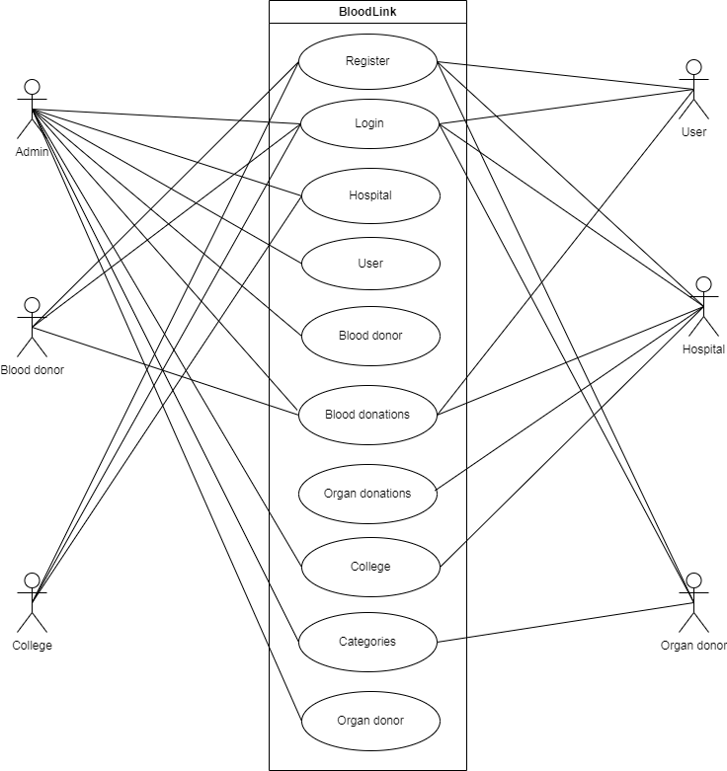

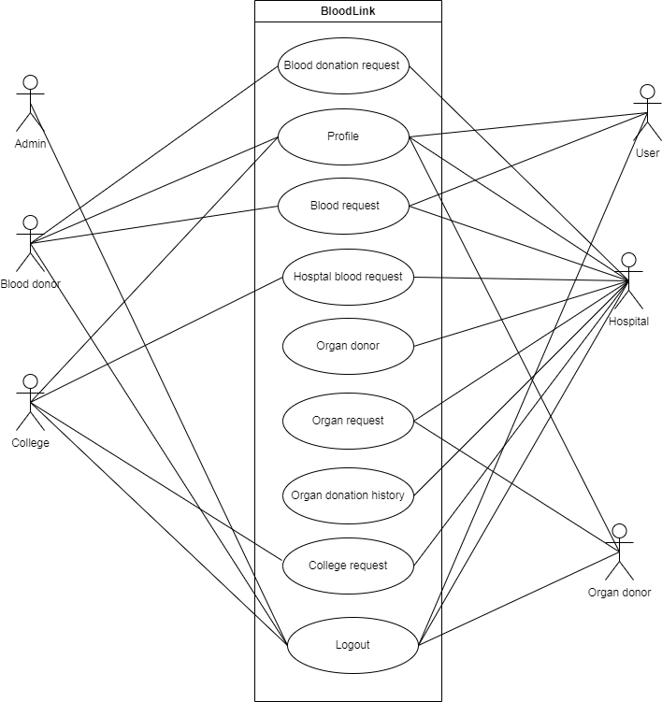

#### 6.5 Scenario

##### Admin:

* Can Login
* Can manage hospital
* Can manage user
* Can manage blood donor
* Can view all donation
* Can manage college
* Can manage organ donor
* Can add categories

**Manager:**

|  |  |
| --- | --- |
|  | * Can register |
|  | * Can login |
|  | * Can manage blood donors request |
|  | * Can view organ donors and send request for organs |
|  | * Can manage organ request from hospital |
|  | * Can assign organ donor |
|  | * Can send organ request to hospital |
|  | * Can manage blood request from hospital |
|  | * Can send blood request to hospital |
|  | * Can manage blood request from user |
|  | * Can manage college request |
|  | * Can send blood request to college |
|  | * Can view blood donation history |
|  | * Can view organ donation history |
|  | * Can edit profile   **College:**   * Can register * Can login * Can send request to hospital * Can view & manage hospital request * Can edit profile * Can view history   **Blood donor:**   * Can register * Can login * Can send request to hospital for blood donation * Can view & manage user request * Can view history * Can edit profile   **User:**   * Can register * Can login * Can send request for blood * View history * Can edit profile   **Organ donor:**   * Can register * Can login * Can view & manage hospital request |

#### 6.6 Sequence Diagram Admin

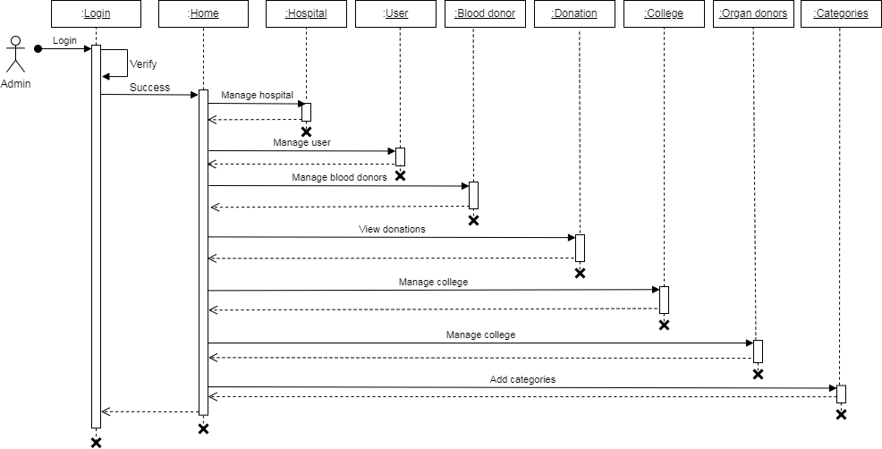

**User**

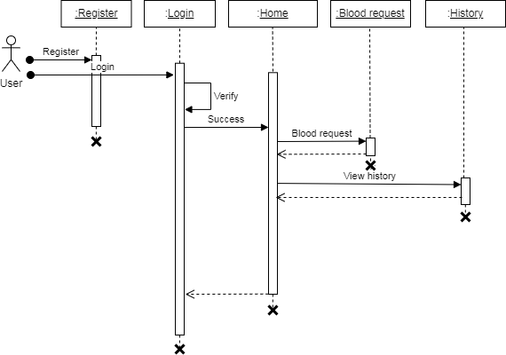

**Blood donor**

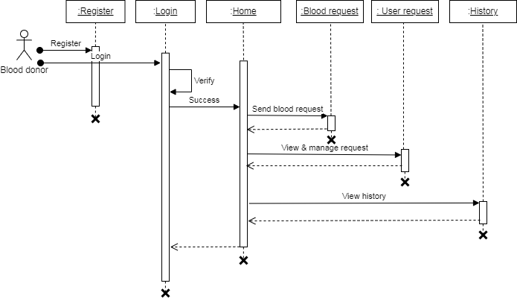

**Hospital**

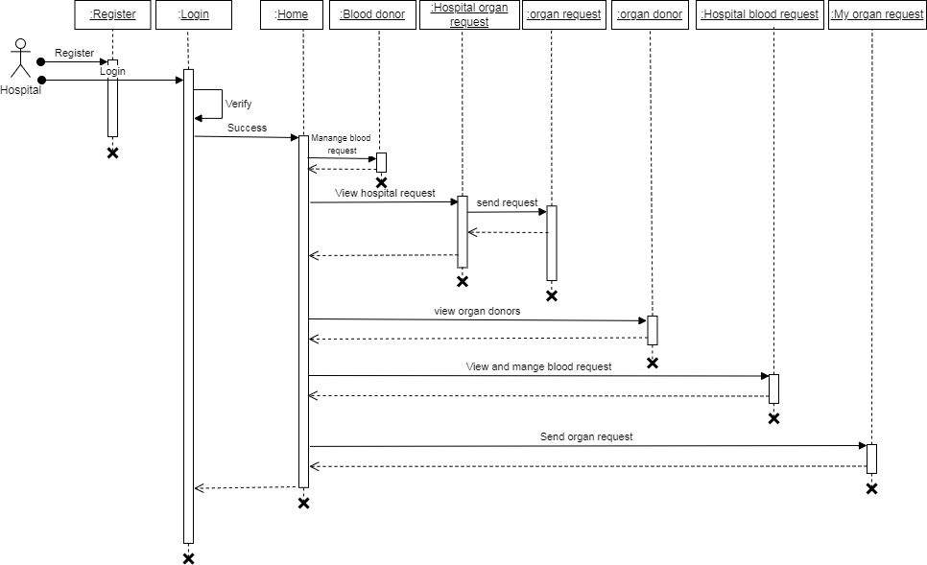

**Hospital**

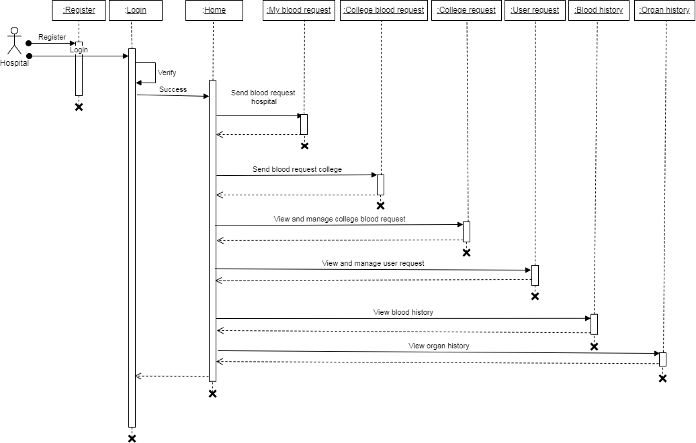

**College**

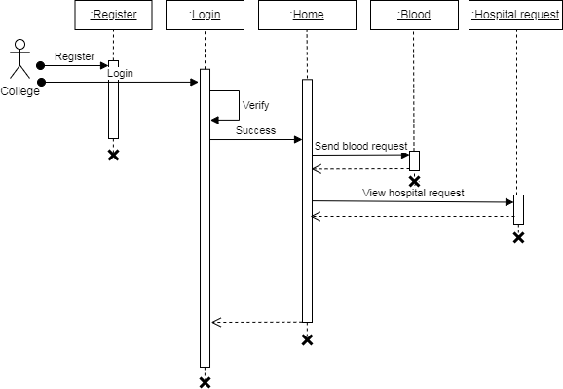

**Organ donor**

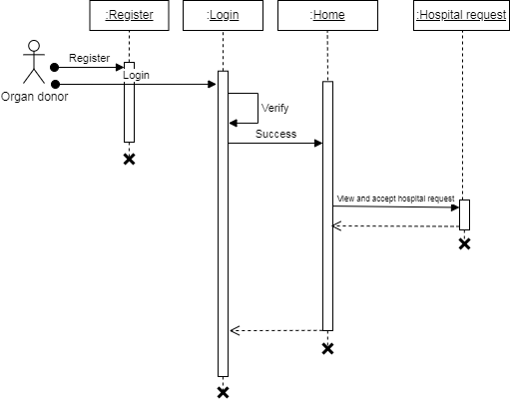

**SYSTEM DEVELOPMENT**

### 7.SYSTEM DEVELOPMENT

System development is series of operations to manipulate data to produce output from computer system. The principle activities performed during the development phase can be divided into two major related sequences.

* External system development
* Internal system development

The major external system activities are:

* Implementation
* Planning
* Equipment acquisition
* Installation

##### 7.1 Coding

The purpose of code is to facilitate the identification and retrieval of items of information. A code is an ordered collection of symbols designed to provide unique identification of an entity or an attribute. Code also shows interrelationship among different items. Codes are used to identify, access, sort, matching records. The code ensures that only one value of code with a single meaning is applied to give an entity or attribute as described in various ways.

##### Node JS

##### Node js is an open-source, cross-platform JavaScript runtime environment that enables developers to build scalable and high-performance applications. It is built on top of the V8 JavaScript engine used by Google Chrome and provides an event-driven, non-blocking I/O model that makes it well-suited for real-time web applications. Node.js enables developers to write server-side applications using JavaScript, which is a popular and widely-used programming language on the web. It has a vast ecosystem of third-party packages and libraries that can be easily installed using the Node Package Manager (NPM). Node js applications can be run on various platforms such as Windows, Mac, and Linux.

##### Express JS

Express.js is a minimal and flexible Node.js web application framework that provides a set of robust features for building web and mobile applications. It is one of the most popular and widely-used frameworks for Node.js, and is known for its simplicity and ease of use. Express.js provides a set of features for developing serverside web applications, including routing, middleware support, template engines, and much more. It also provides an easy-to-use API for interacting with databases such as MongoDB and MySQL, and supports a variety of templating engines, such as Pug, Handlebars, and EJS..

##### Mongo DB

MongoDB is a popular document-oriented NoSQL database system that allows developers to store and manage large amounts of data in a flexible and scalable way. It is an open-source database that uses JSON-like documents with optional schemas, which makes it easy to work with and suitable for a variety of use cases. One of the key benefits of MongoDB is its ability to scale horizontally. This means that developers can add new servers to their database cluster as the amount of data or traffic increases, which allows the database to handle more requests and ensures that it can continue to perform well even as the application grows.

## SYSTEM TESTING AND IMPLEMENTATION

### 8.SYSTEM TESTING AND IMPLEMENTATION

Testing is vital to the success of the system. It makes a logical assumption that if all the parts of the system are correct, the goal will be successfully achieved in this project. It is the stage of implementation, which ensures that the system works accurately and effectively before the live operation commences. It is a confirmation that all are correct and an opportunity to show users that the system must be tested and show that the system will operate successfully and produce expected results under expected conditions. Software testing is a crucial element of software quality assurance and represents the unlimited review of specification, design and coding. Testing represents an interesting anomaly for the software. During the earlier definition and development phase, it was attempted to build the software from an abstract concept to implement.

Testing is a set of activities that can be planned in advance and conducted. Systematically, this is aimed at ensuring that the system works accurately and efficiently before live operations commences

#### Types of Testing

#### Different types of testing are:

#### Unit testing

#### Black box testing

#### Integration testing

#### System testing

#### White box testing

##### Unit testing

Unit testing is usually conducted as part of a combined code and unit test phase of the software lifecycle, although it is not uncommon for coding and unit testing to be conducted as two distinct phases. All modules were tested individually as soon as they were completed and were checked for their correct functionality. Unit testing deals with testing a unit as a whole. This would test the interaction of many functions but confine the test within one unit. This testing is carried out during the

programming stage itself. In this testing step each Module is found to be working satisfactorily as regard to the expected output from the module.

##### Black box testing

In black-box testing the structure of the program is not considered. Test cases are decided solely on the basis of the requirements or specifications of the program or module, and the internals of the module or the program are not considered for selection of test cases. In black-box testing, the tester only knows the inputs that can be given to the system and what output the system should give. This form of testing is also called functional or behavioural testing. The most obvious functional testing procedure is exhaustive testing. One criterion for generating test cases is to generate them randomly. There are no formal rules for designing test cases for functional testing.

**Integration testing**

Integration testing plays a critical role in software development by verifying the interactions and interfaces between different modules or components. This testing phase ensures that the integrated components work together seamlessly as intended, detecting any inconsistencies or communication issues early in the development process. By executing integration tests, software teams can validate the flow of data, control, and interfaces between modules, contributing to the overall stability and functionality of the system.

**System testing**

System testing is a comprehensive evaluation of the entire software system to confirm that it meets the specified requirements and functions correctly in its intended environment. This testing phase involves testing the system as a whole, including all integrated components, subsystems, and external interfaces. By simulating real-world scenarios and user interactions, system testing verifies the system's behavior, performance, and reliability, ensuring that it delivers the expected outcomes to end-users and stakeholders.

**White box testing**

White-box testing is a software testing approach that delves deep into the internal structure, logic, and code of a software application. Unlike black-box testing,

which focuses solely on evaluating the functionality from an external perspective, white-box testing involves examining the inner workings of the software, including the source code and system architecture. Testers or developers performing white-box testing have access to the codebase and utilize various techniques such as statement coverage, branch coverage, and path coverage to ensure thorough test coverage. By analyzing the code's control flow, data flow, and execution paths, white-box testing aims to uncover defects, vulnerabilities, and inconsistencies within the software early in the development process. This type of testing not only validates the correctness and integrity of the code but also promotes code quality, maintainability, and efficiency. White-box testing is essential for ensuring robustness, reliability, and security in software applications, as it provides insights into the inner workings of the software and facilitates effective debugging and optimization efforts. Overall, white-box testing plays a vital role in the software development lifecycle by complementing other testing approaches and ensuring the overall quality and reliability of the software product.

.

## SYSTEM MAINTENANCE

### 9.SYSTEM MAINTENANCE

Maintenance is making adaptation of the software for external changes (requirements changes or enhancements) and internal changes (fixing bugs). When changes are made during the maintenance phase all preceding steps of the model must be revisited.

There are 3 types of maintenance:

* Corrective (Fixing bugs/errors)
* Adaptive (Updates due to environment changes)
* Perfective (Enhancements, requirements changes)

Maintenance is enigma of the system development. The definition of the software maintenance can be given describing four activities that are undertaken after the program is released for use. The maintenance activity occurs since it is unreasonable to assume that software testing will uncover all in a large system. The second activity that contributes the definition of maintenance occurs since rapid changes are encountered in every aspects of computing. The third activity involves recommendation for new capabilities, modification to the existing functions and general enhancements when the software is used. The fourth maintenance activity occurs when software is changed to improve future maintainability or reliability.

## FUTURE ENHANCEMENT

### 10.FUTURE ENHANCEMENT

In the future, LifeLink plans to introduce features such as mobile apps for easier access and notification systems to alert donors about urgent needs. Additionally, there will be efforts to expand the network to include more hospitals, colleges, and potential donors, thus increasing the availability of blood and organs. By leveraging emerging technologies such as artificial intelligence and blockchain, LifeLink seeks to ensure the highest standards of security, efficiency, and ethical practices throughout its operations. Through ongoing partnerships with medical institutions, educational organizations, and community groups, LifeLink remains committed to its mission of saving lives and enhancing the quality of healthcare worldwide.

Furthermore, the platform aims to incorporate advanced data analytics to predict and manage donation trends more effectively, ensuring a steady supply of blood and organs when needed. These enhancements will further streamline the donation process and ultimately improve healthcare services and community well-being.

## CONCLUSION

### 11.CONCLUSION

The LifeLink web application is designed to streamline the blood and organ donation processes by fostering seamless collaboration between hospitals, colleges, and donors. Through its user-friendly interfaces and transparent systems, LifeLink ensures efficient communication and protects sensitive information. By encouraging active participation from communities, the project aims to instill a culture of giving within the healthcare ecosystem. LifeLink's web app makes it easier for hospitals, colleges, and donors to work together. By getting communities involved, it wants to make helping others a normal part of healthcare. This collaborative network not only enhances accessibility to donations but also ensures a timely response to medical needs, ultimately leading to improved healthcare services and overall community well-being.

**APPENDIX**

**12.APPENDIX**

**Landing page**

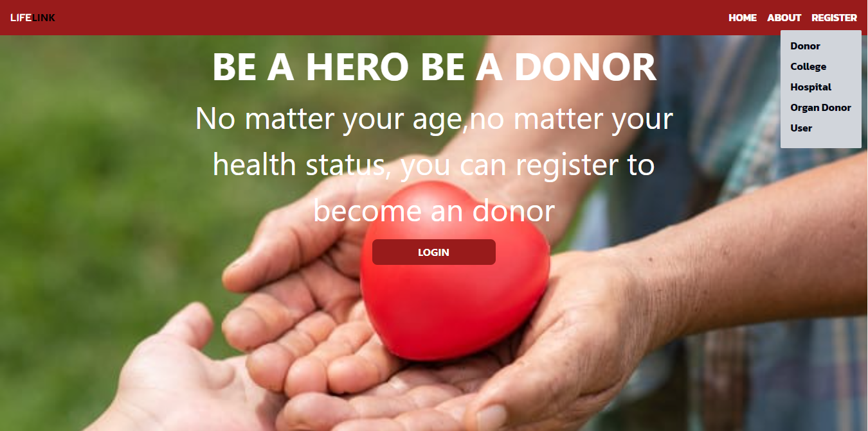

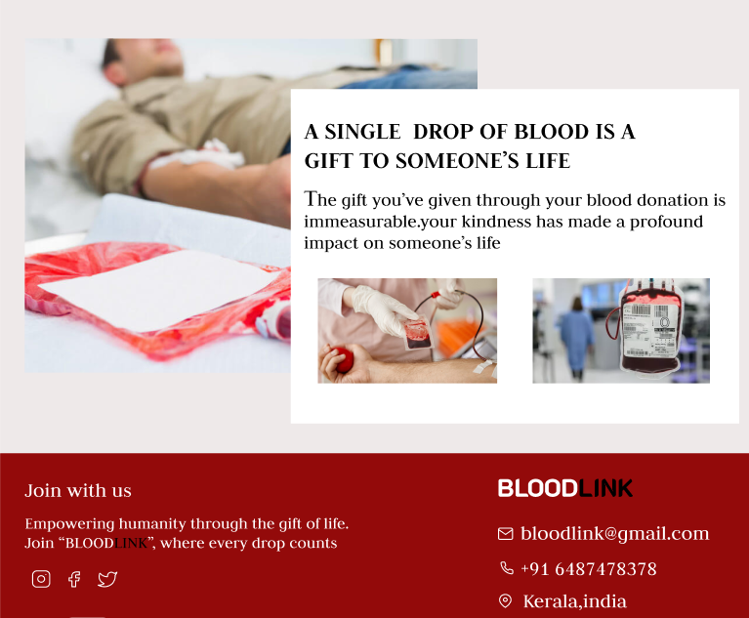

**hospital registration**

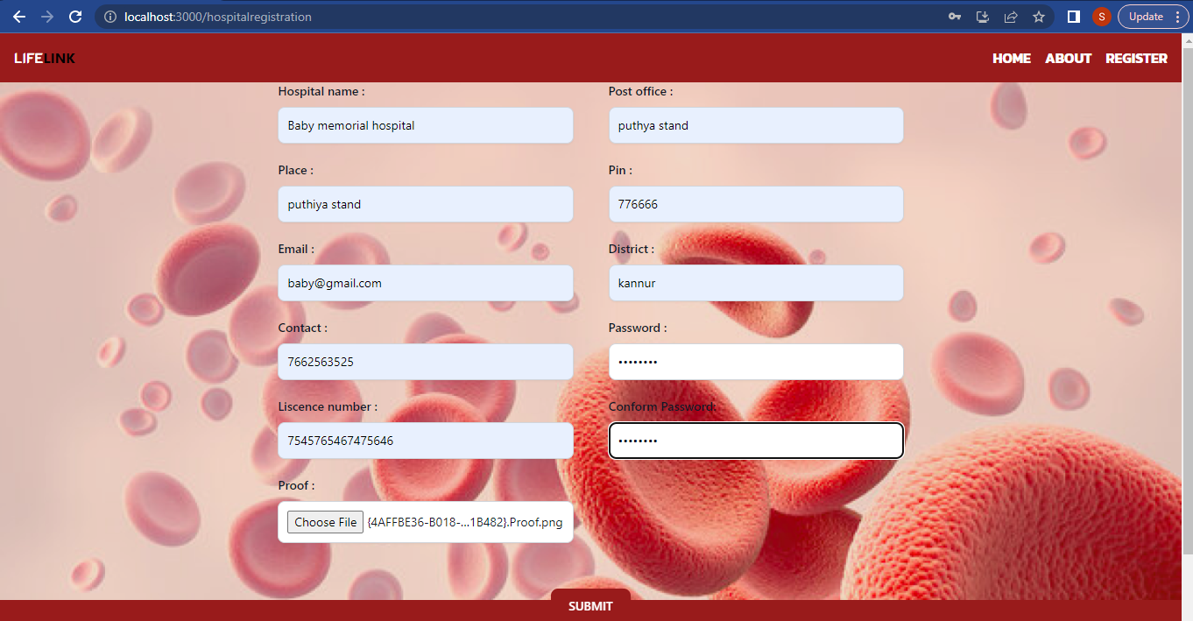

**User registration**

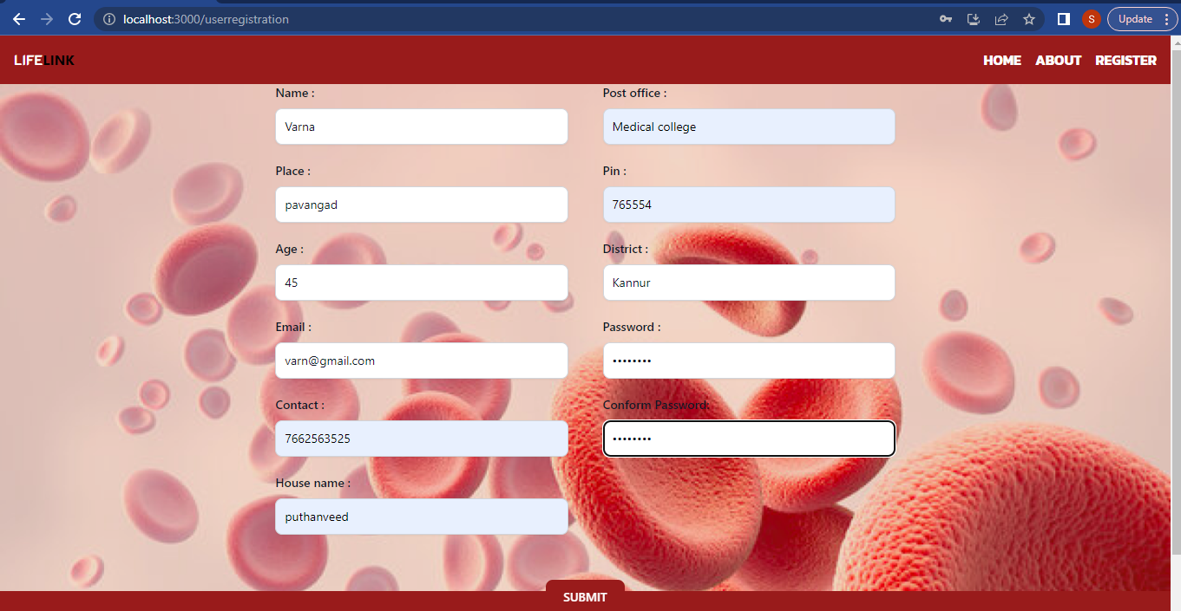

**College registration**

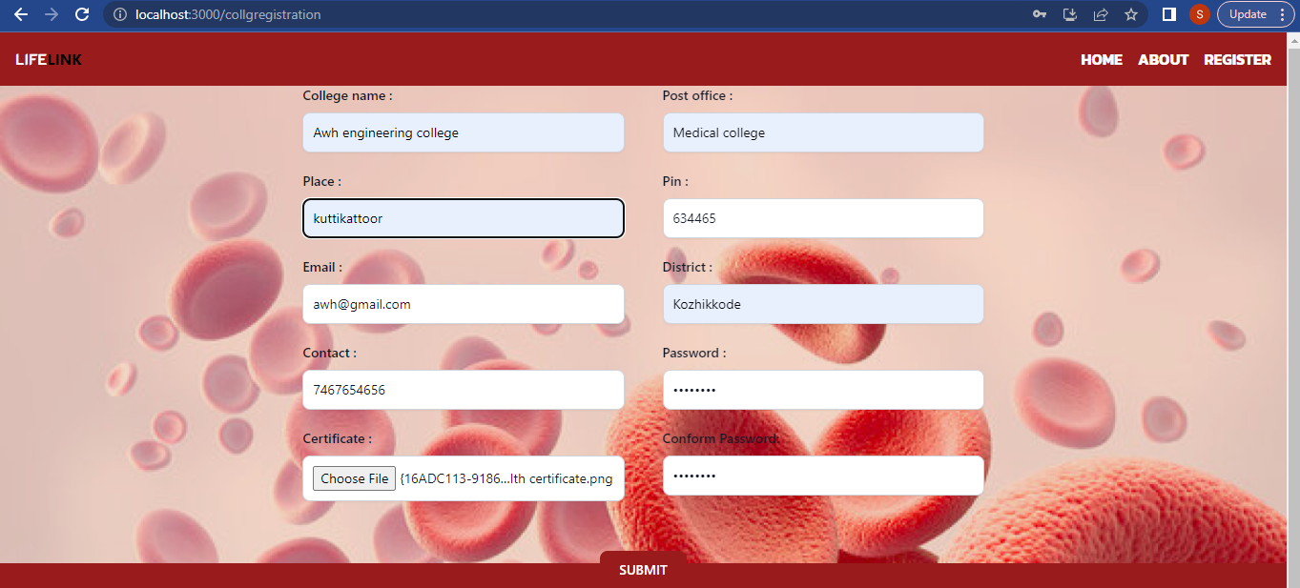

**Blood donor registration**

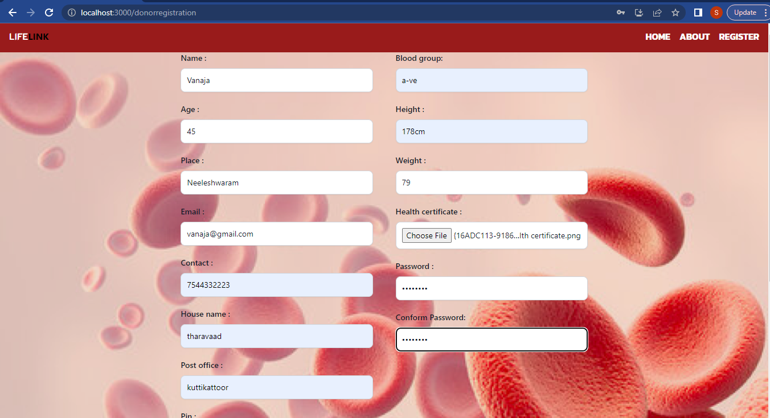

**Organ donor registration**

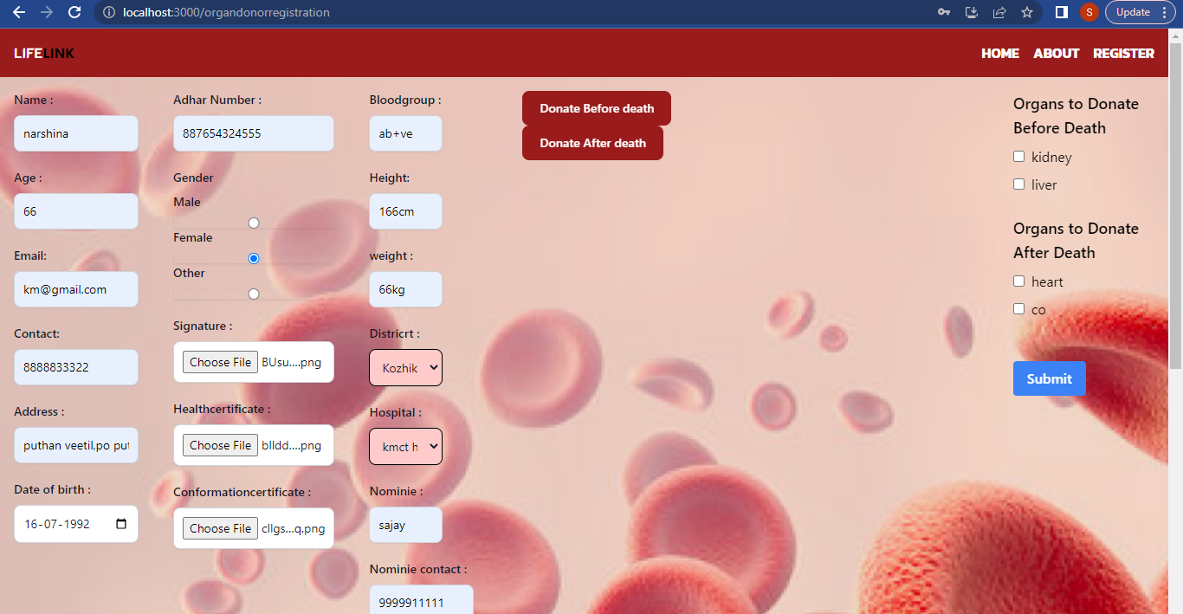

**Login page - hospital**

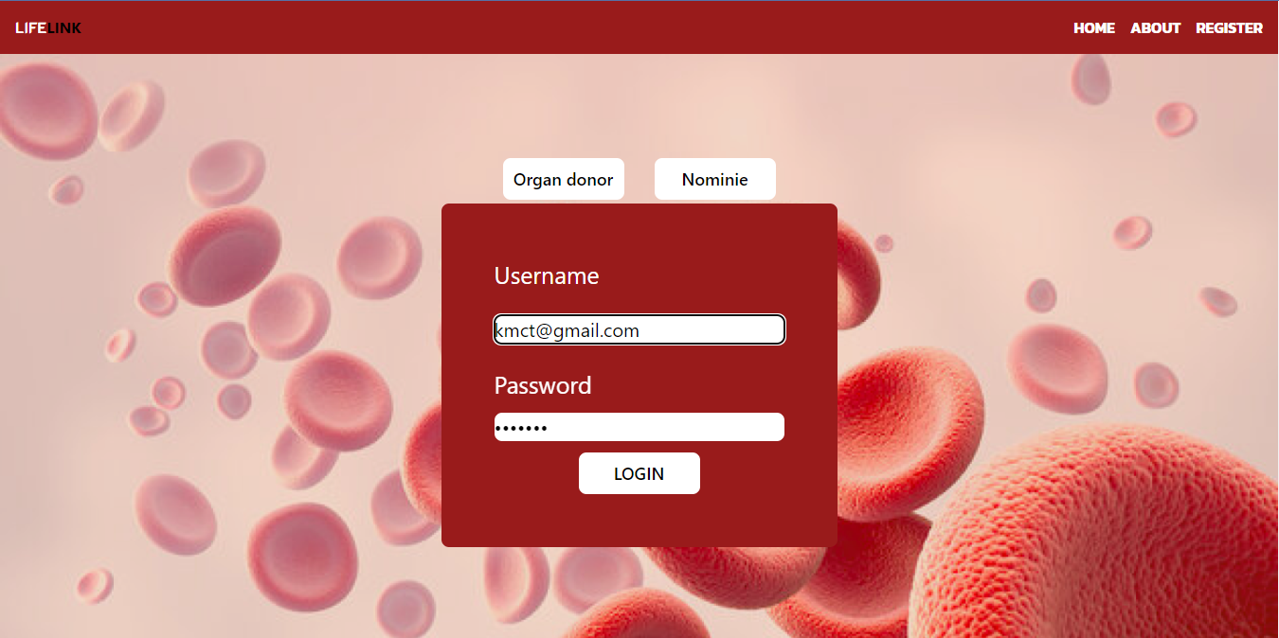

**Admin manage hospitals**

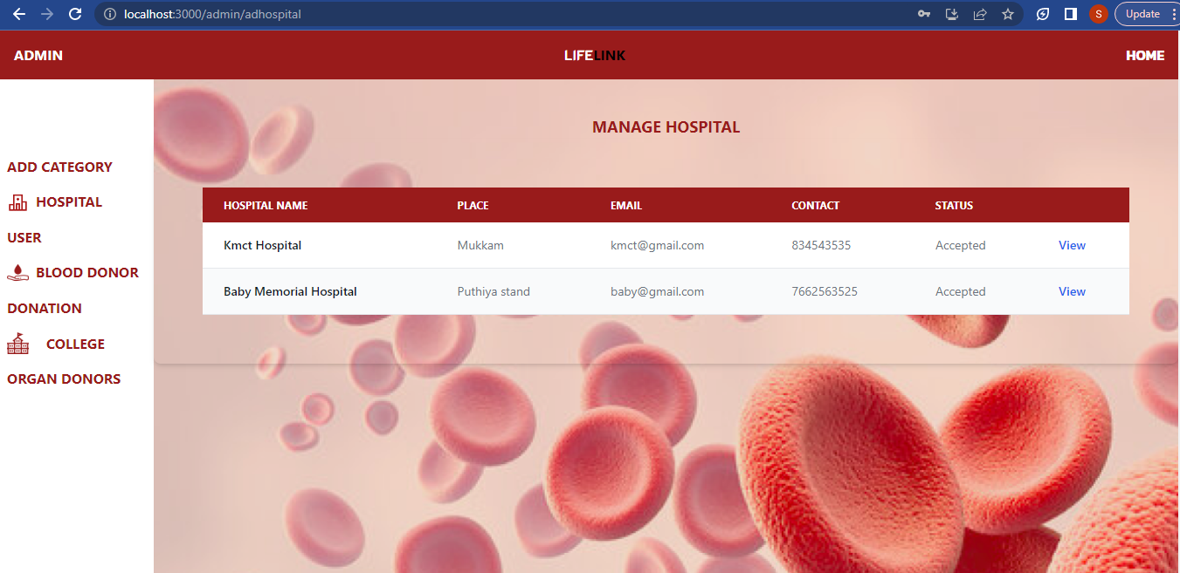

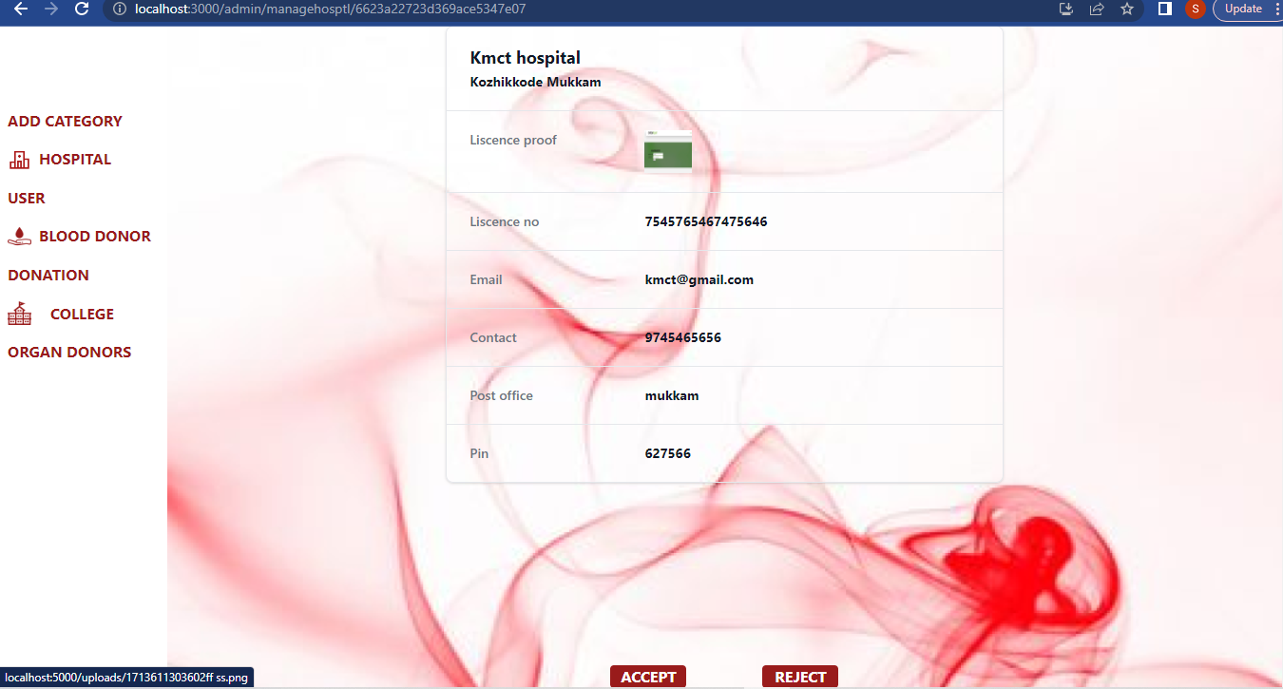

**Admin manage college**

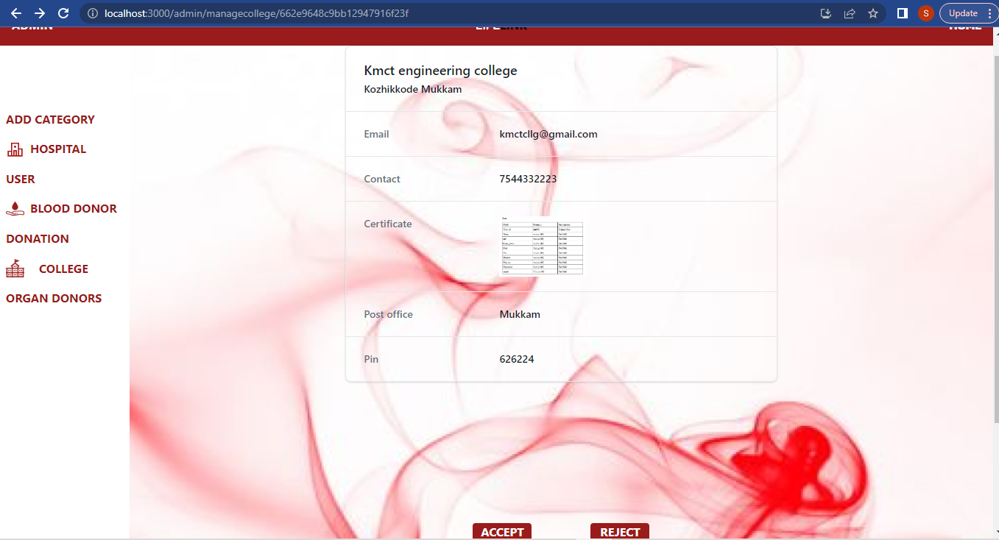

**Admin manage blood donors**

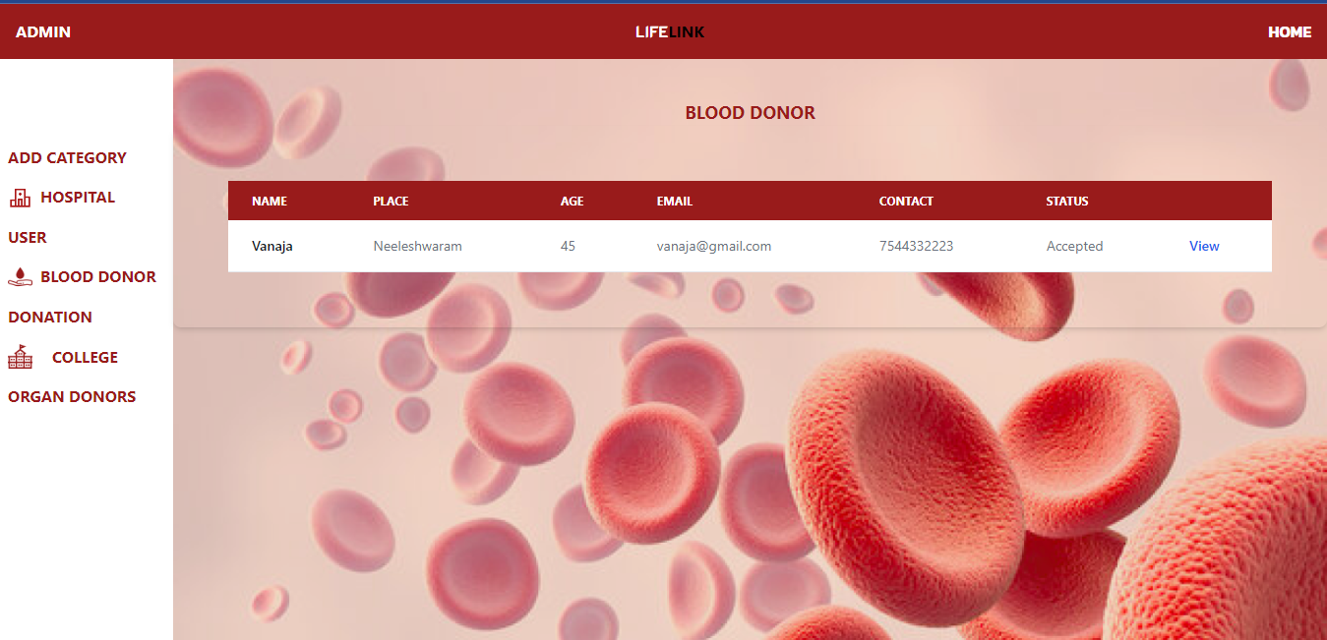

**Admin manage user**

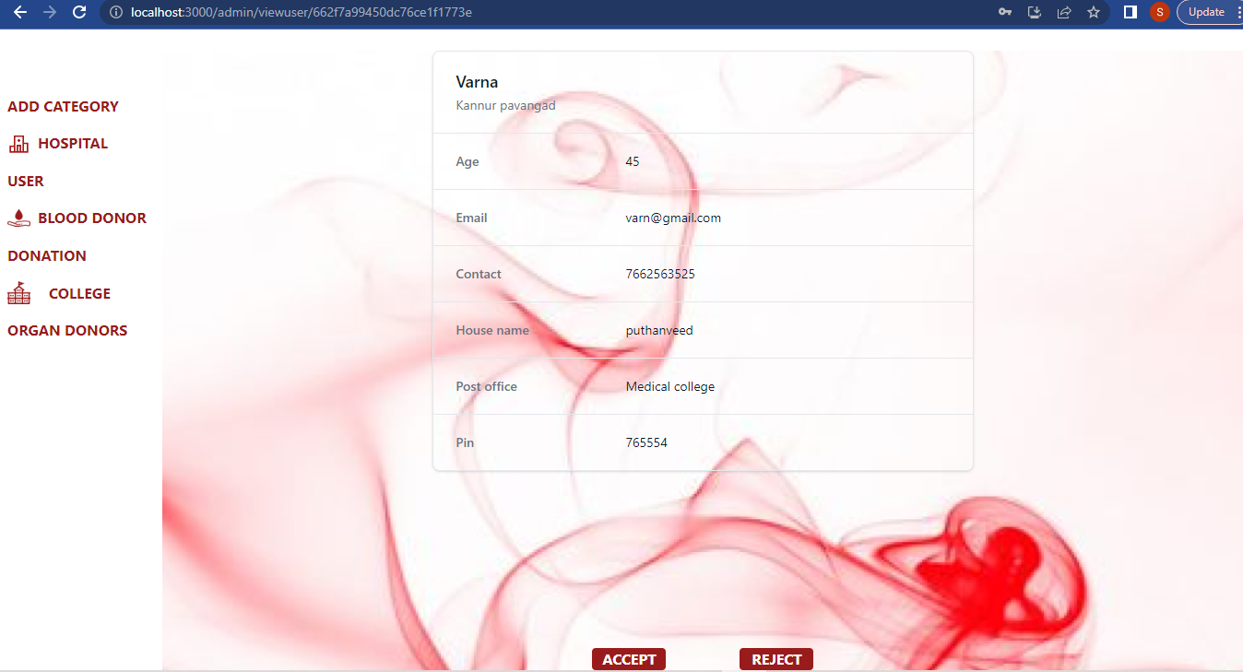

**Admin all view donations**

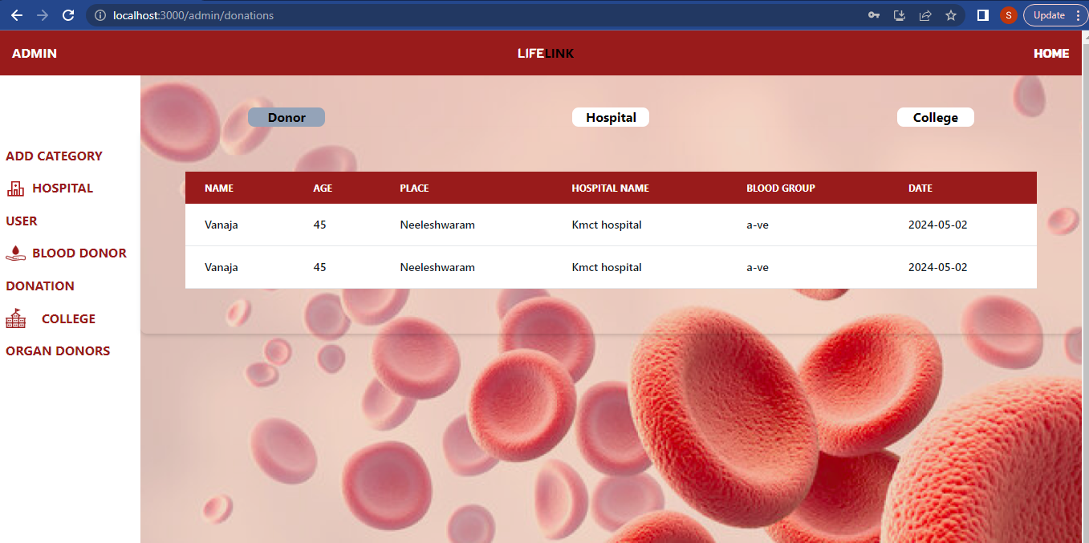

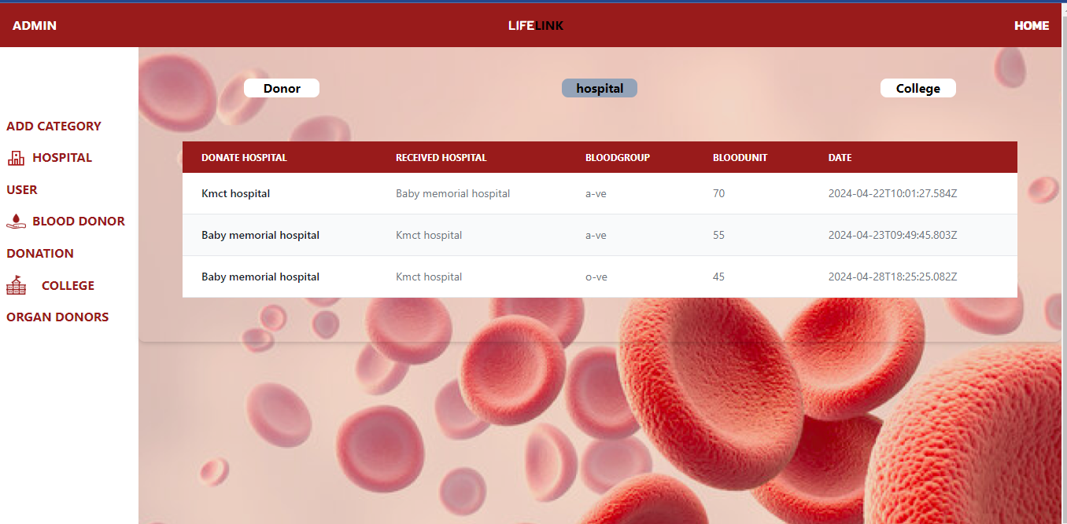

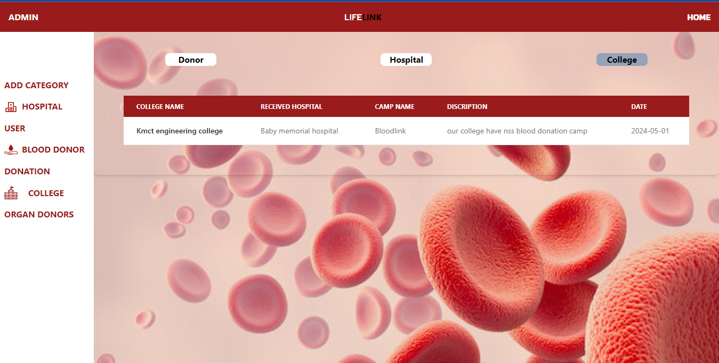

**Admin manage organ donor**

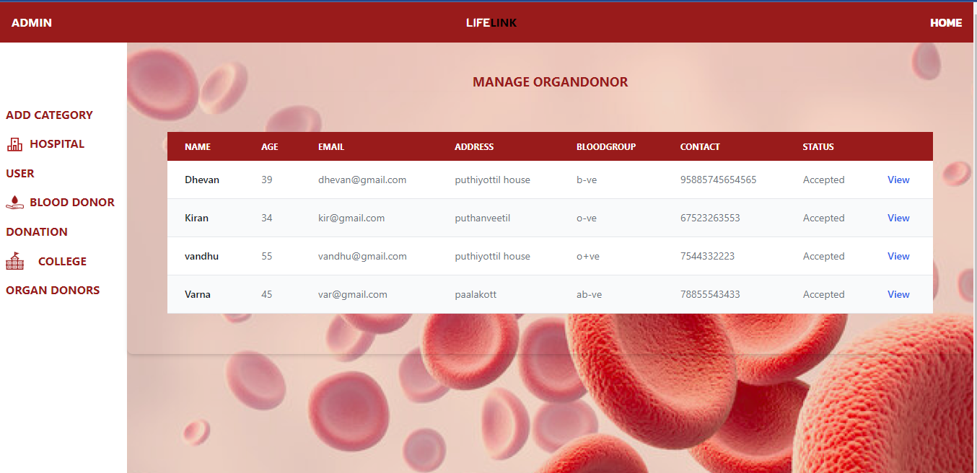

**Admin add categories**

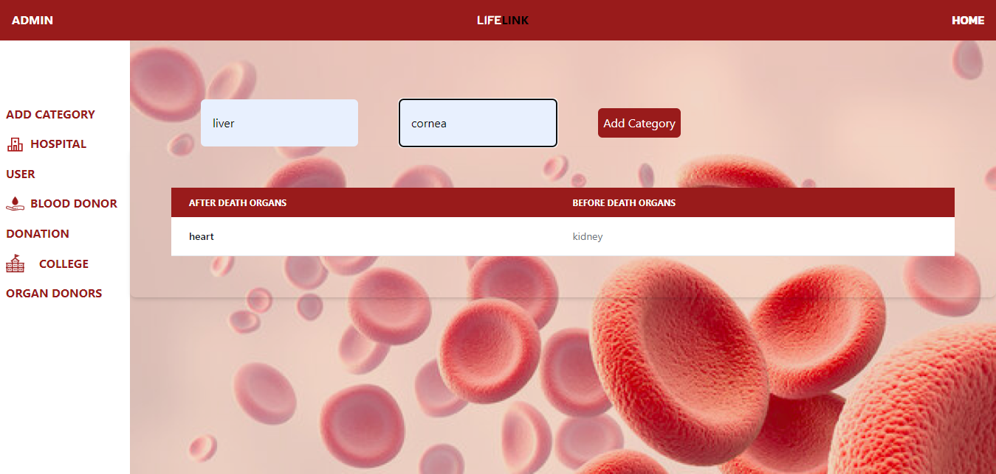

**Blood donors home page**

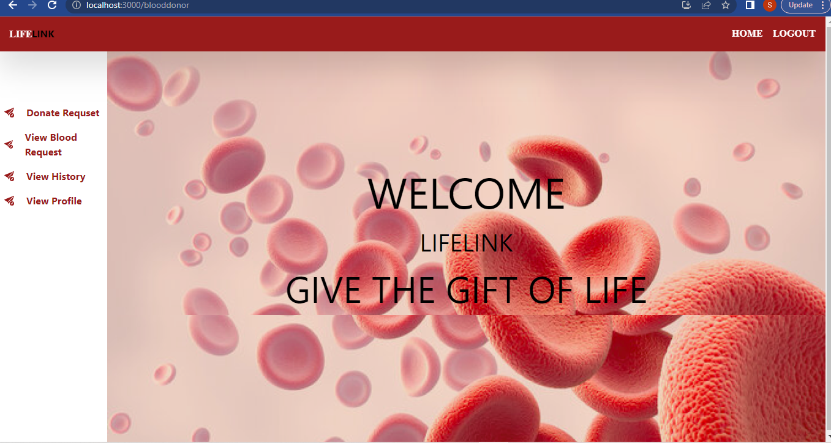

**Blood donor send request**

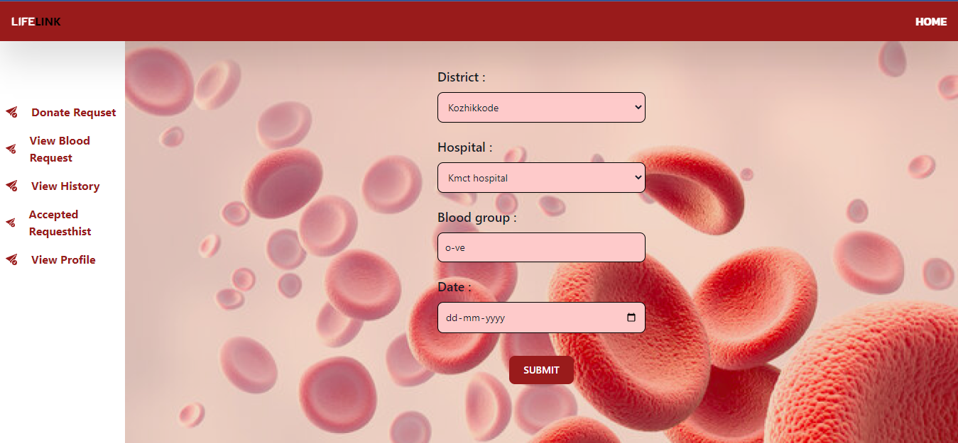

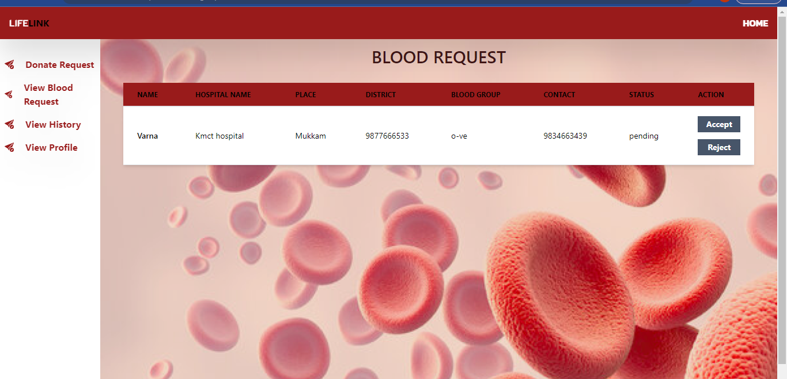 **Blood donor view user request**

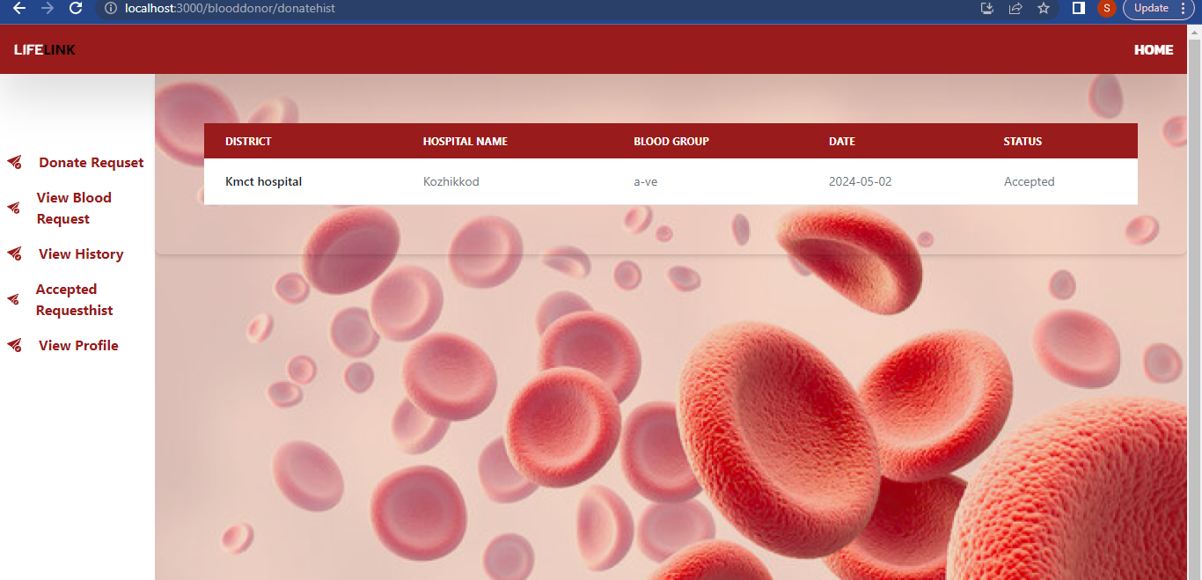 **Blood donor view history**

**Blood donor update profile**

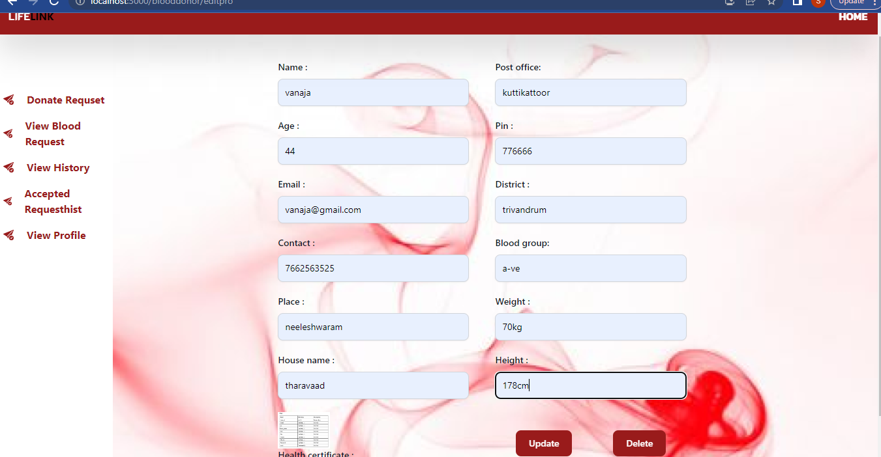

**Hospital home page**

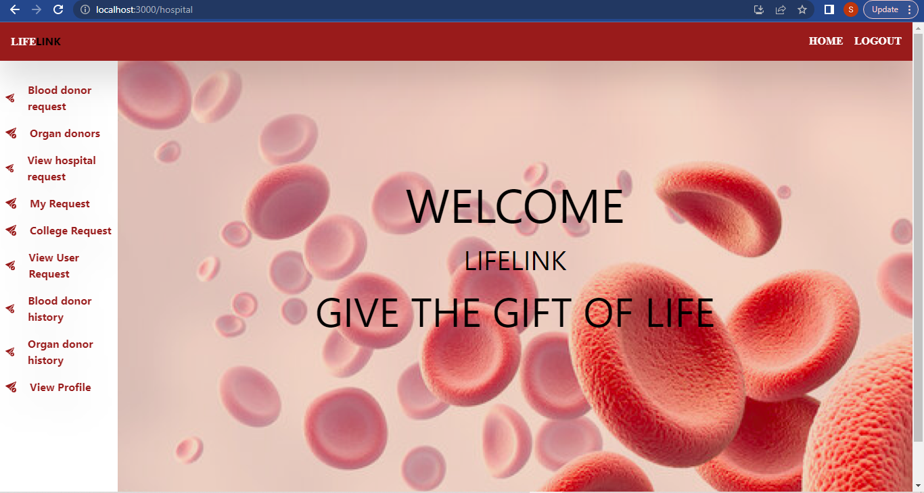

**Hospital Manage blood donor request**

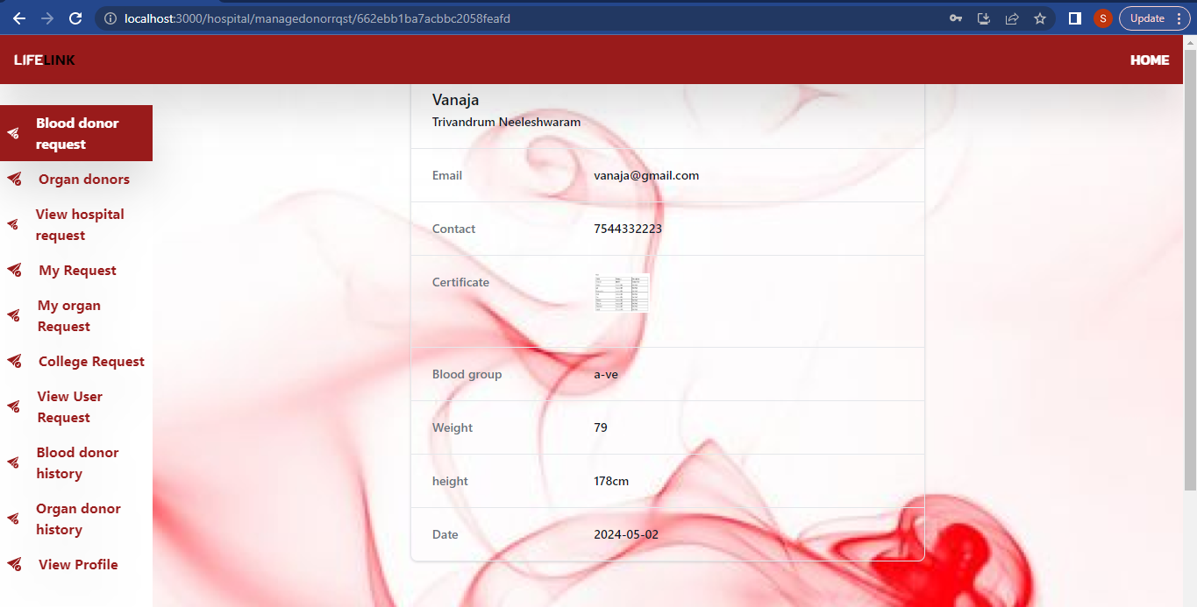

**Hospital view organ donors**

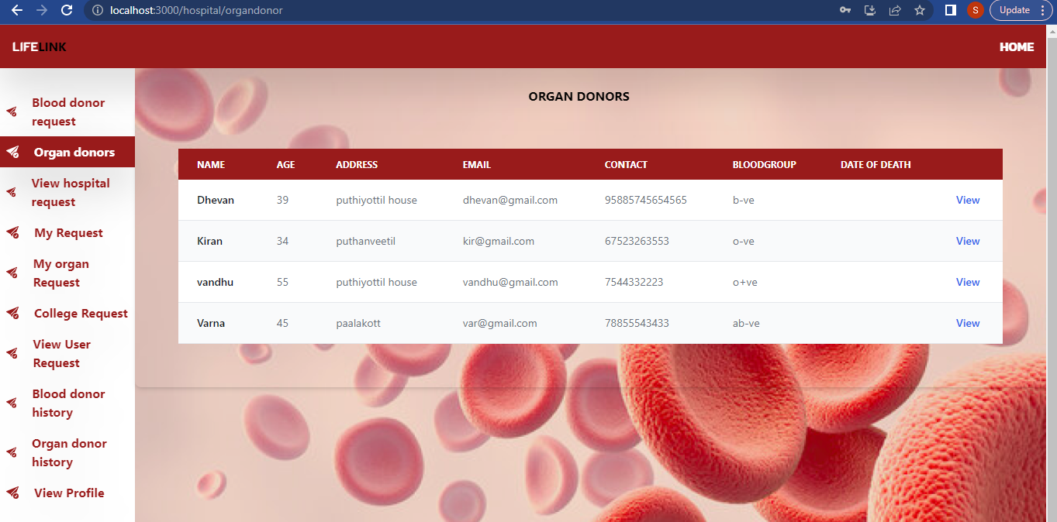

**Send request to organ donor**

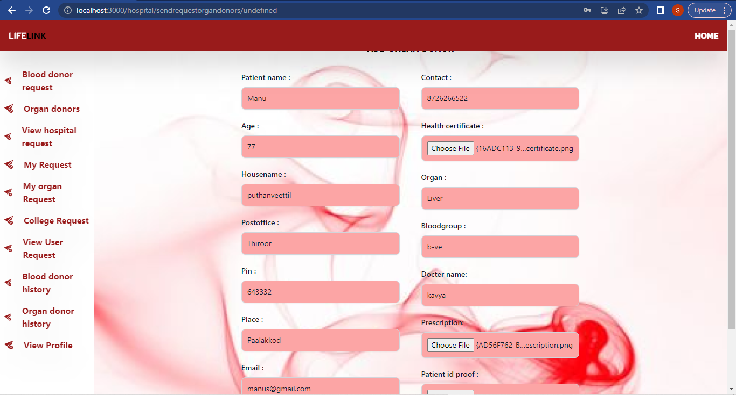

**Hospital view hospital blood request**

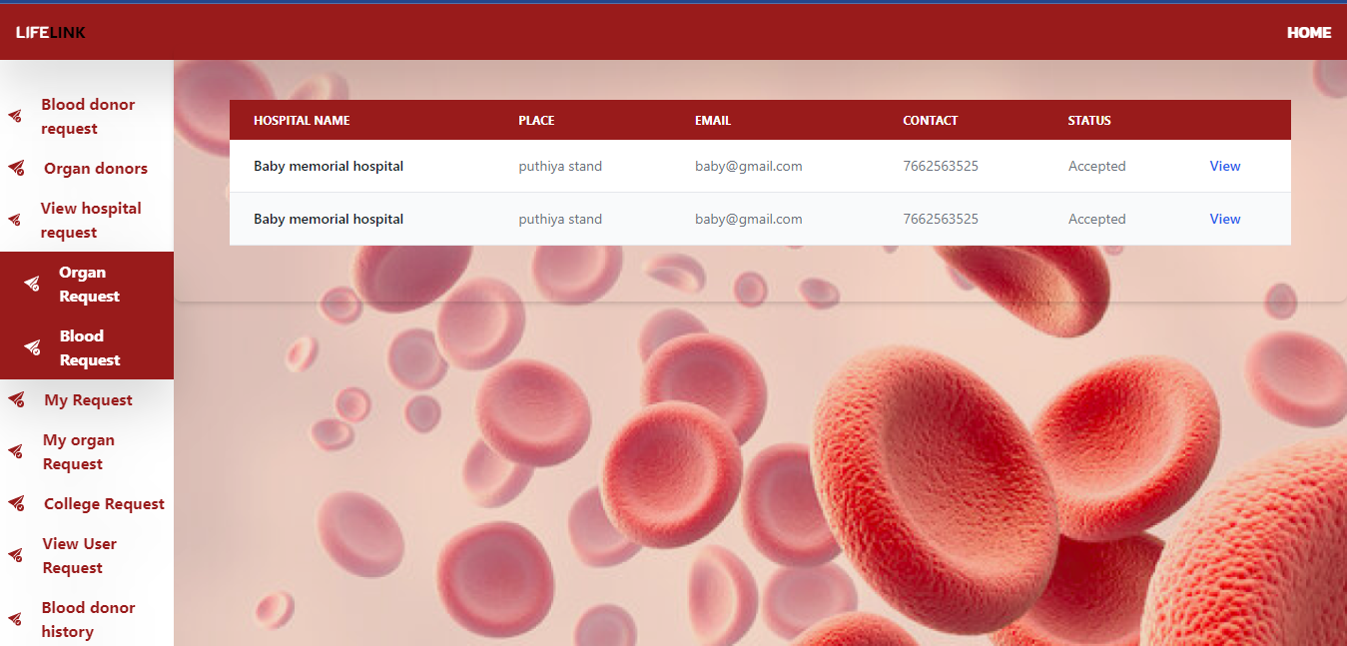

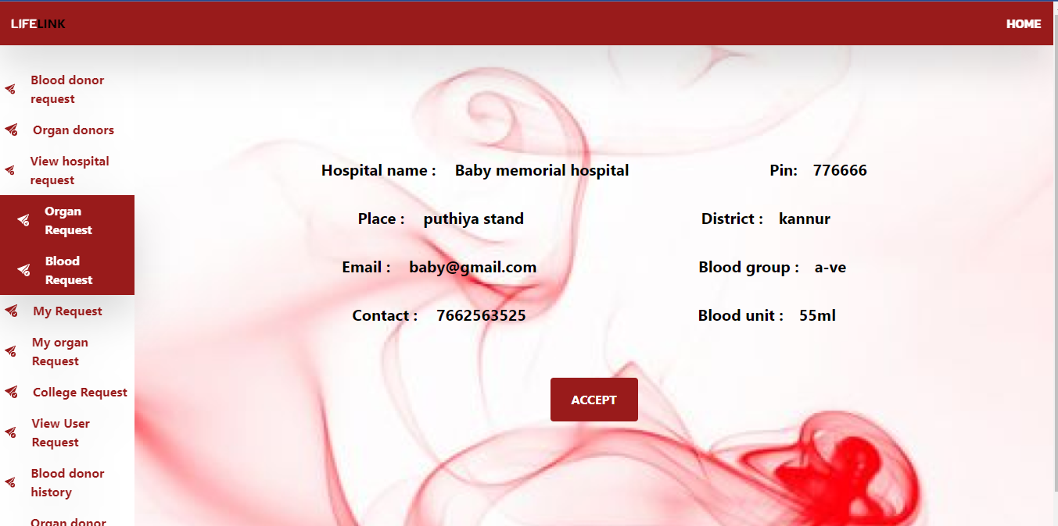

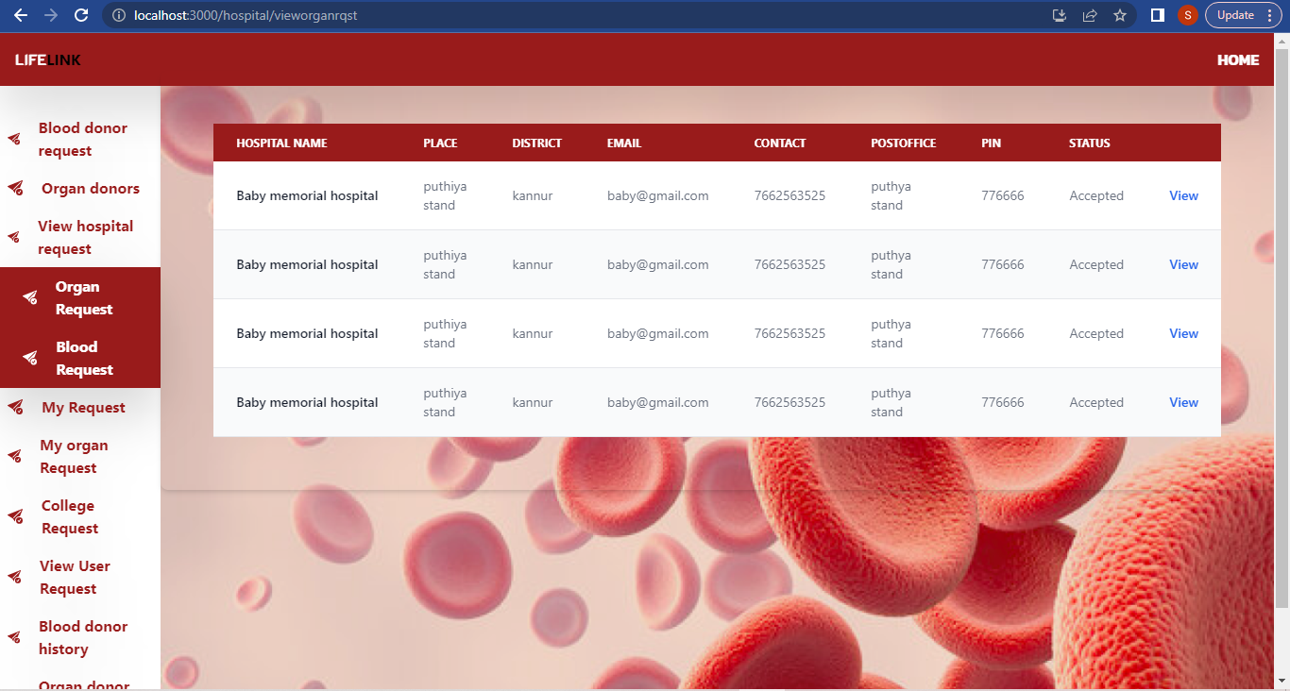 **Hospital view organ request**

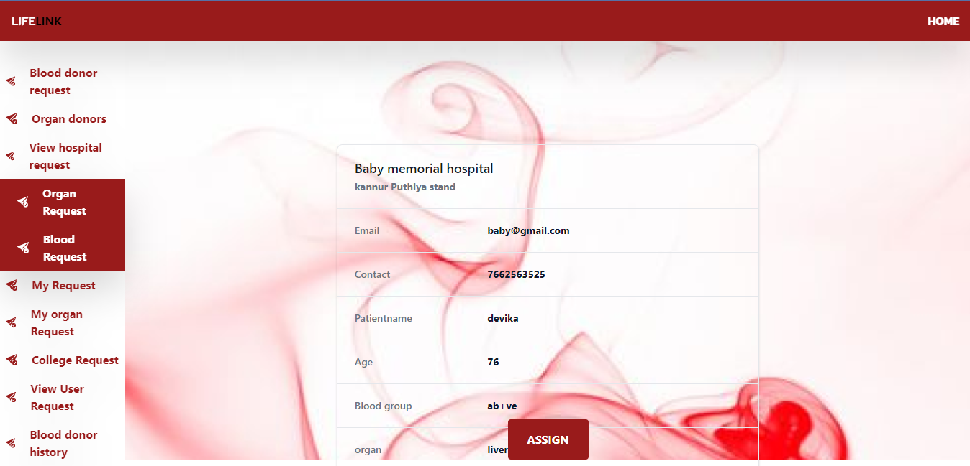

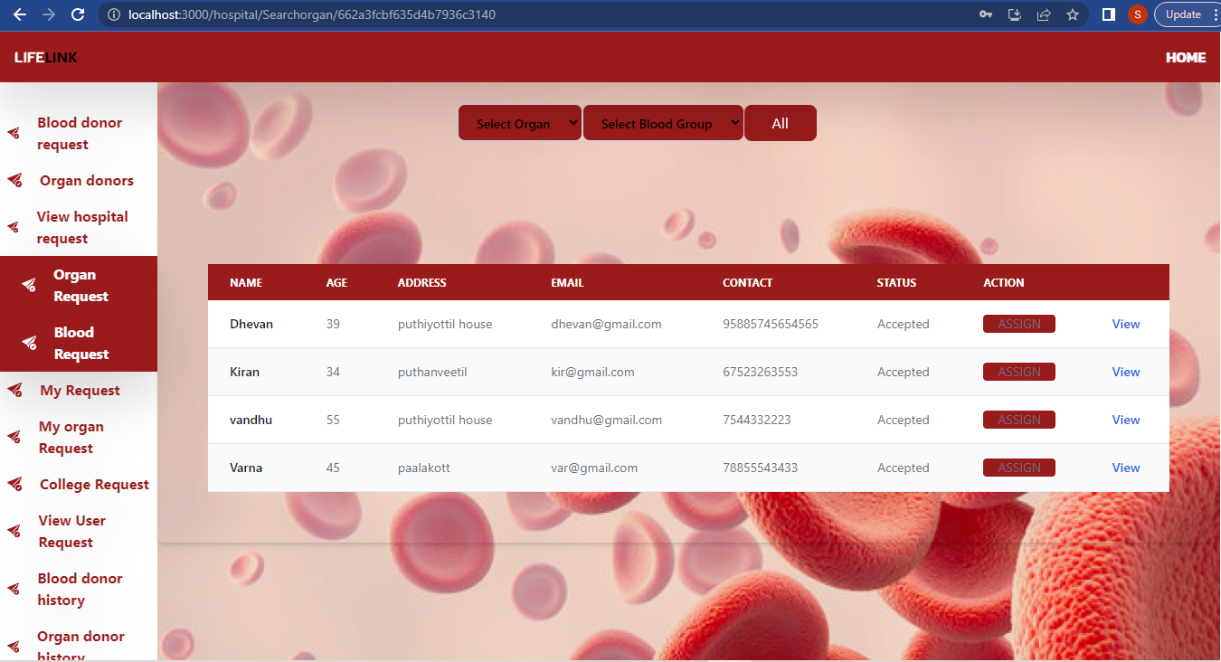 **Hospital send request to organ donor**

**Hospital add organ request**

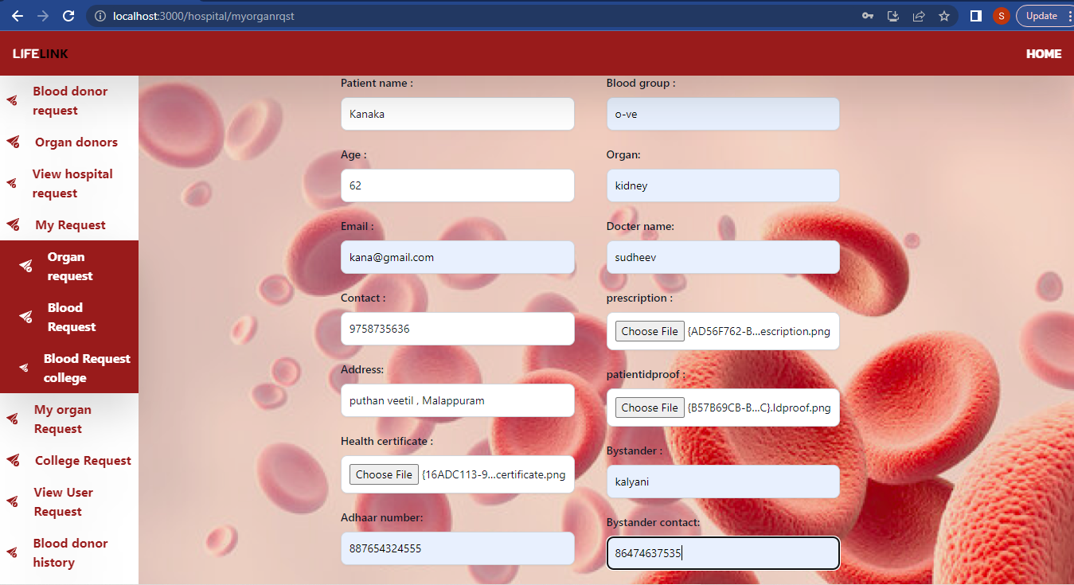

**Hospital add blood request to hospital**

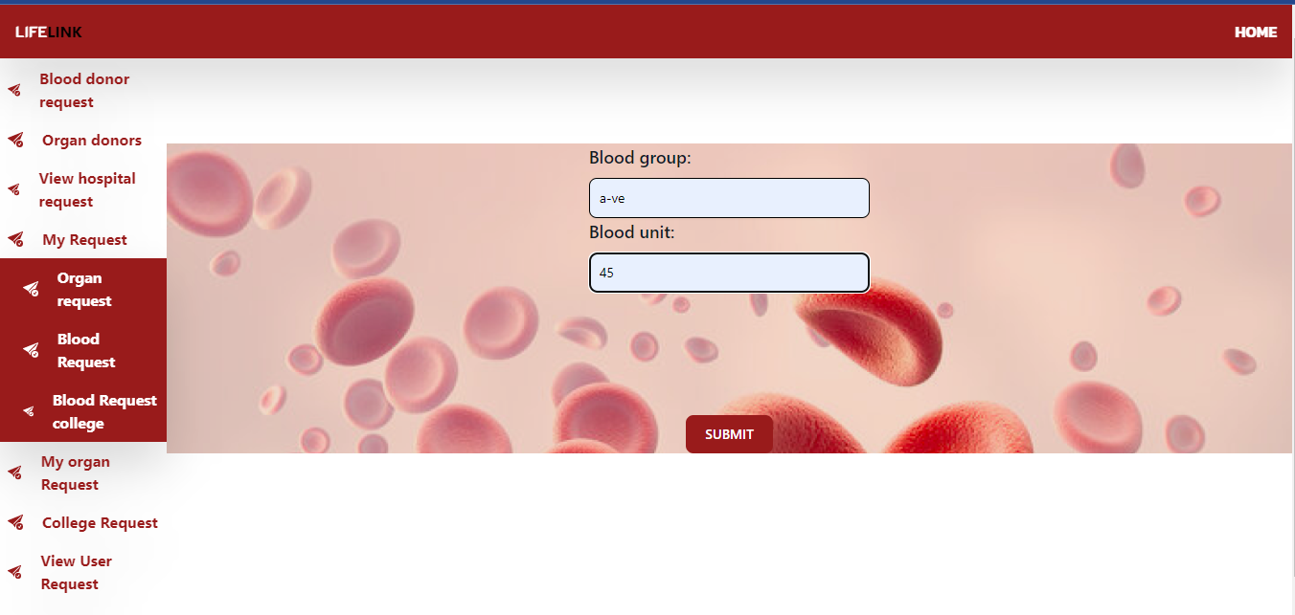

**Hospital send blood request to college**

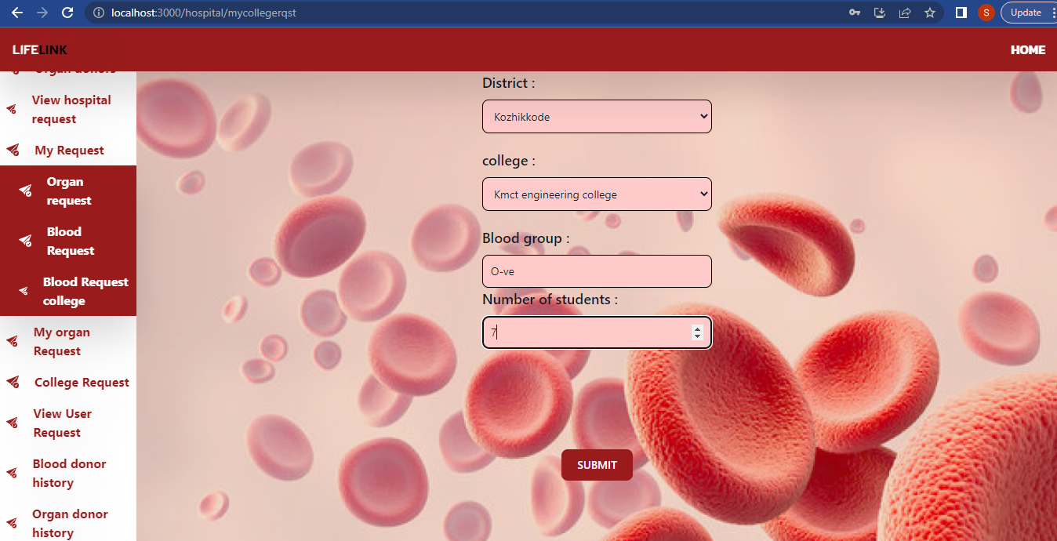

**Hospital manage college request**

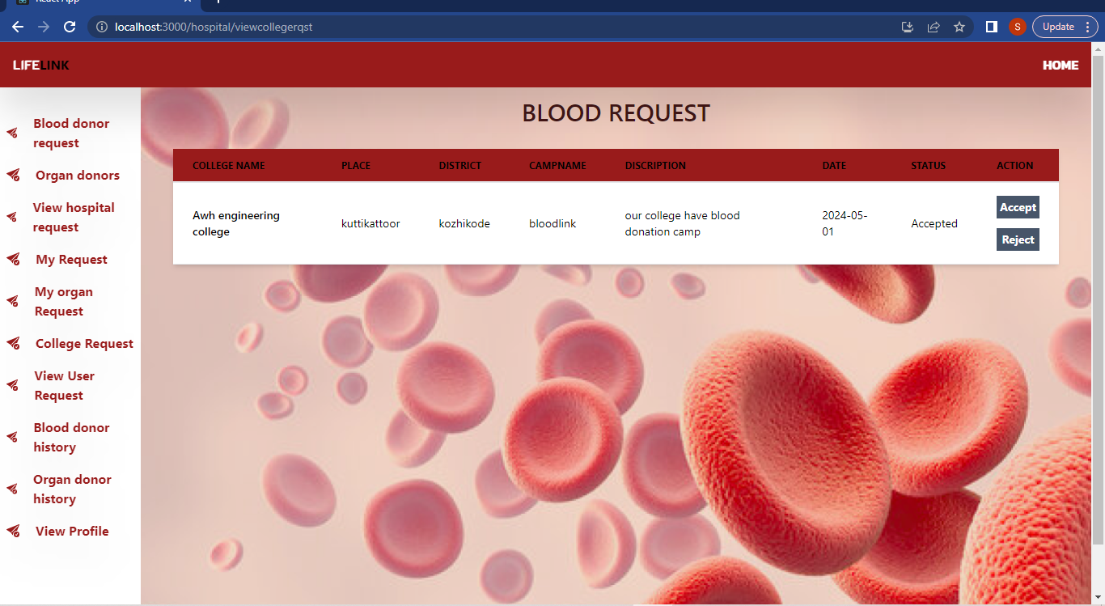

**Hospital manage user request**

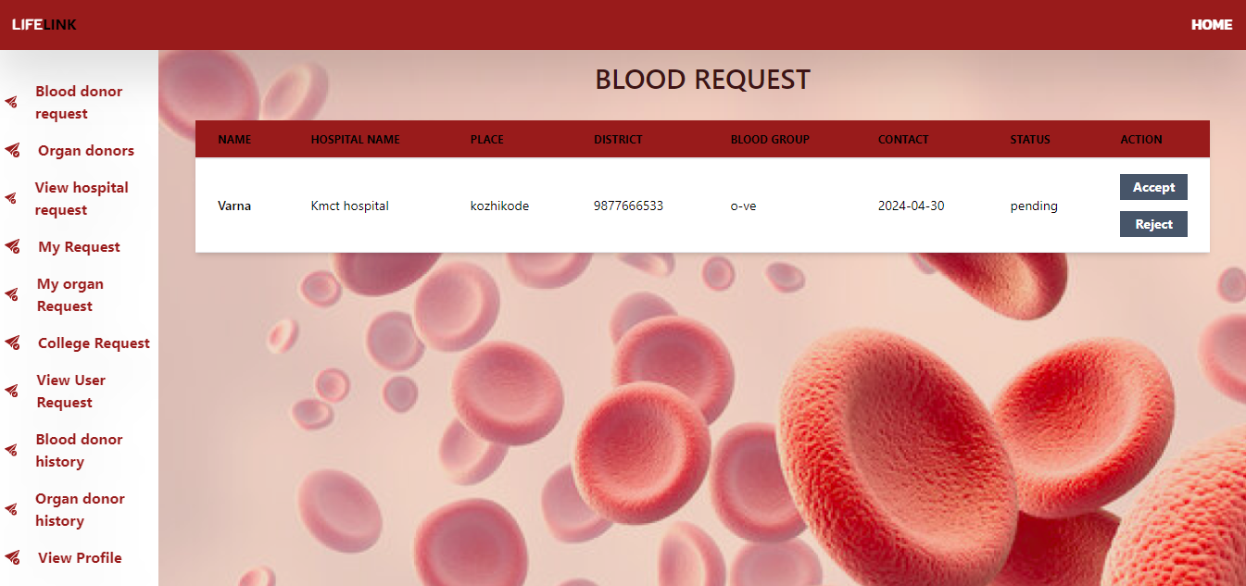

**Hospital view blood donor history**

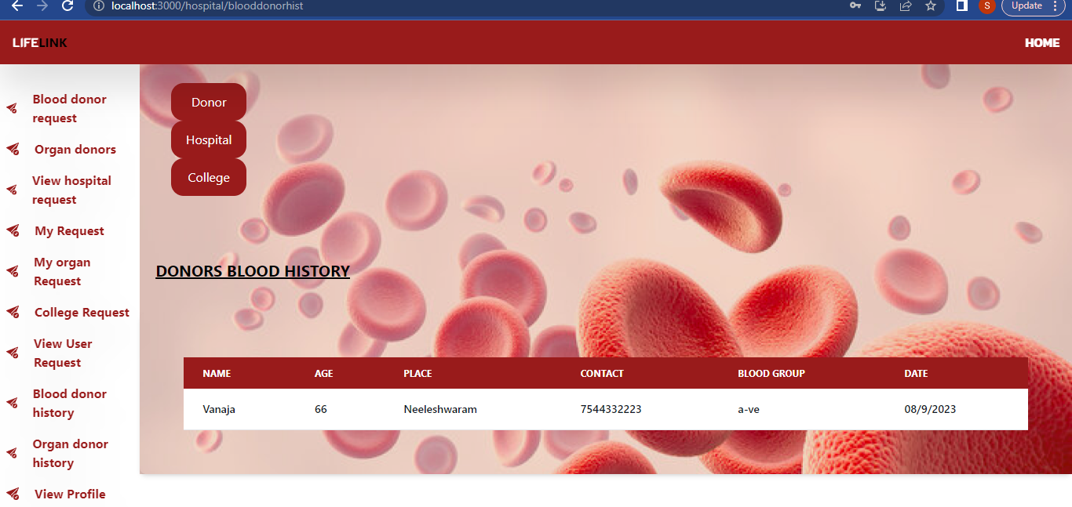

**Hospital view hospital send and received blood request**

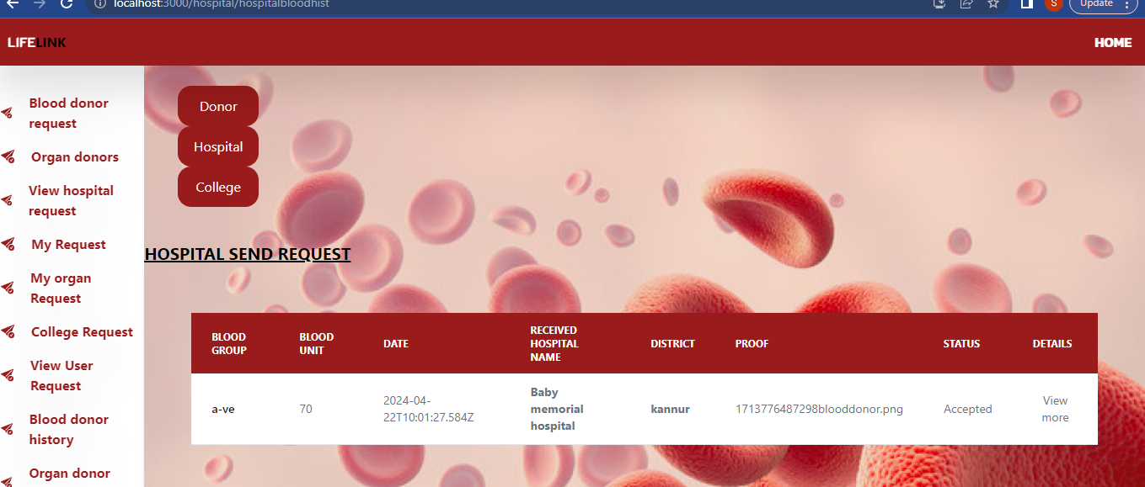

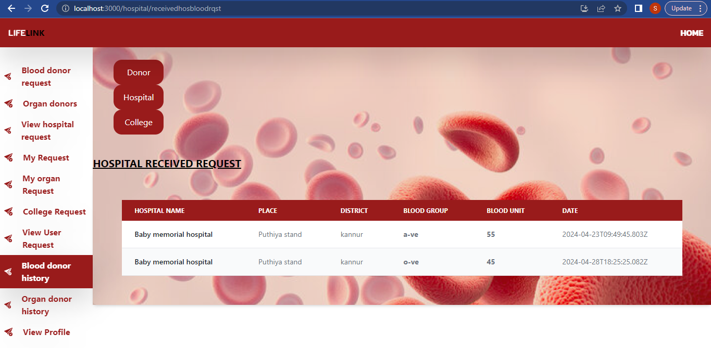

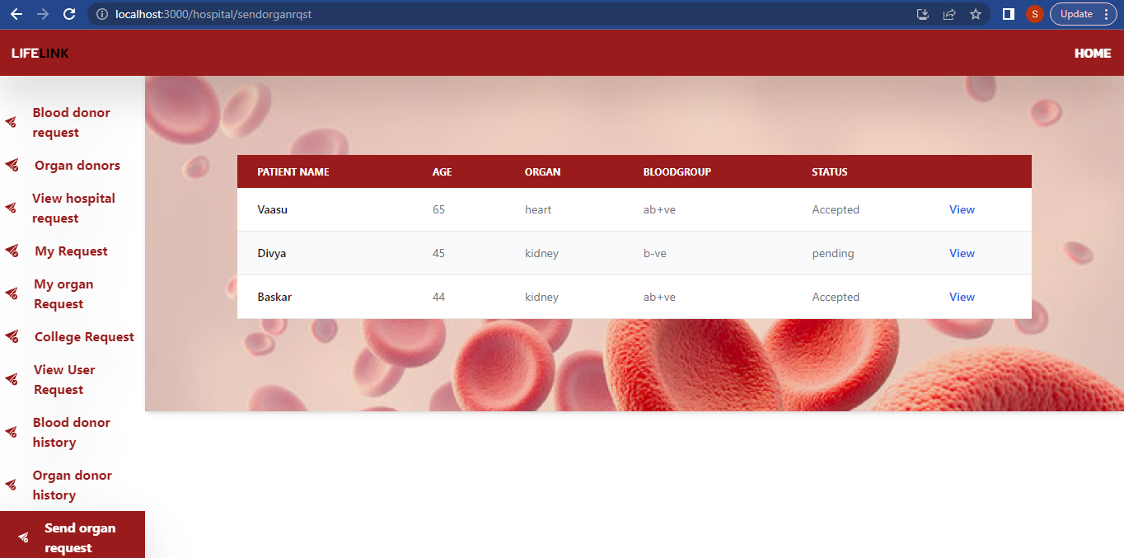 **Hospital view send request to organ donor**

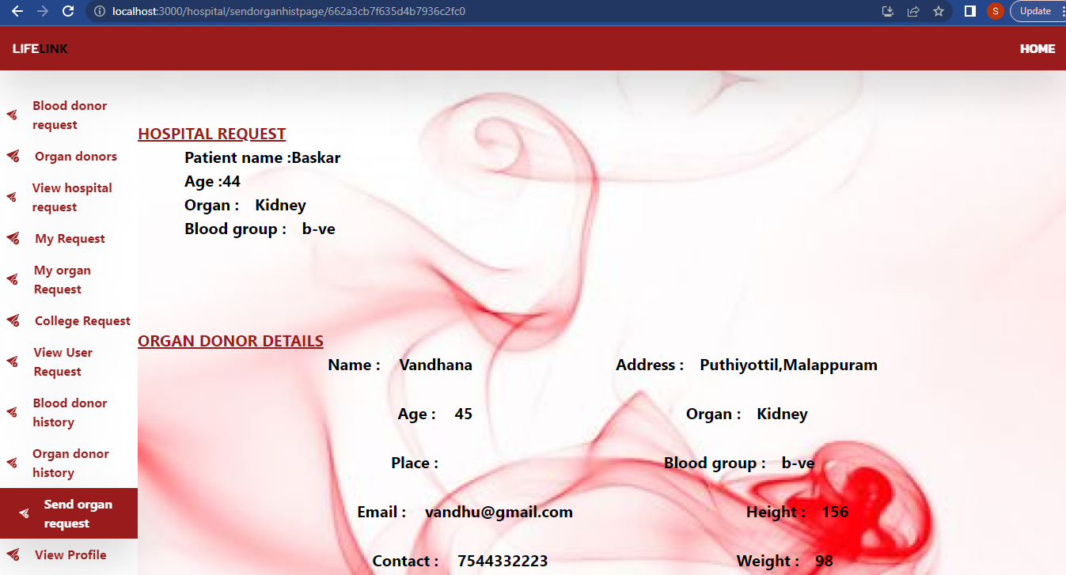

**Hospital update profile**

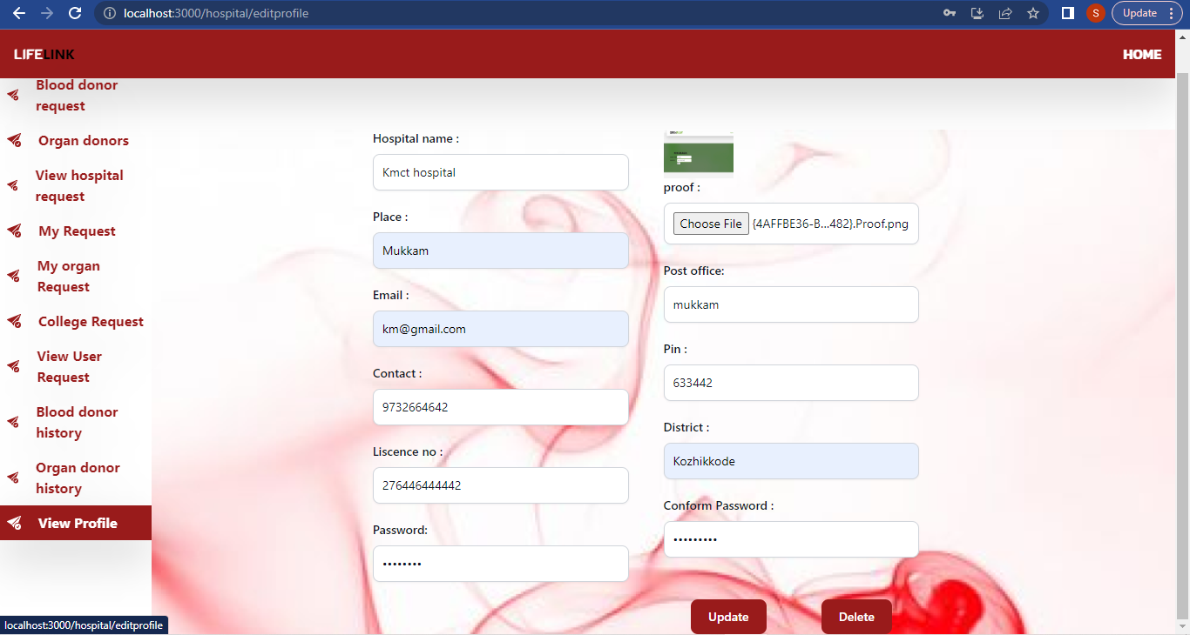

**College home page**

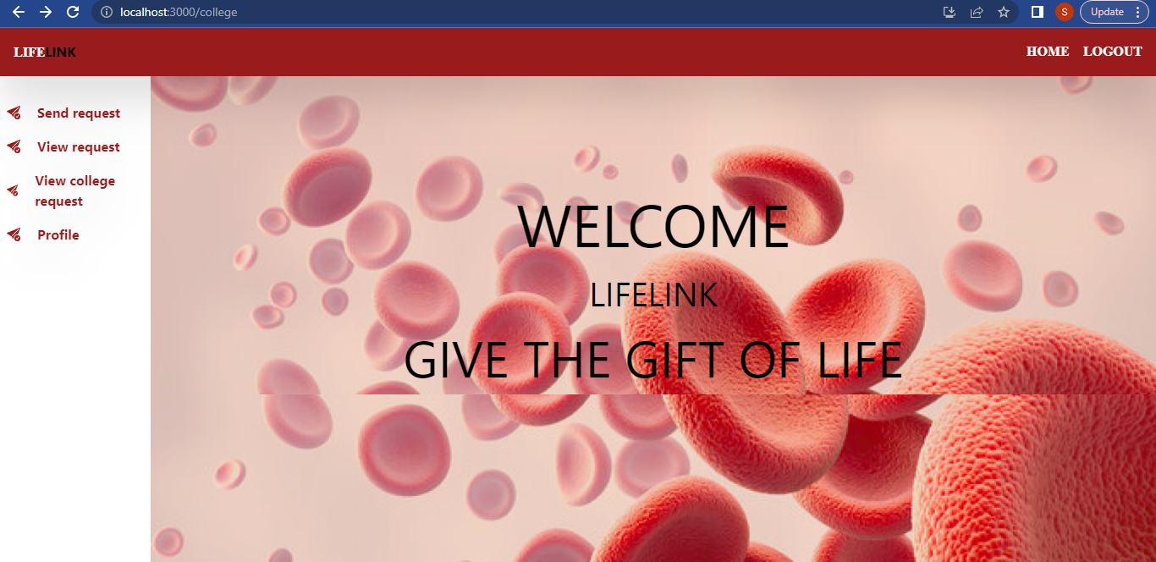

**College send request**

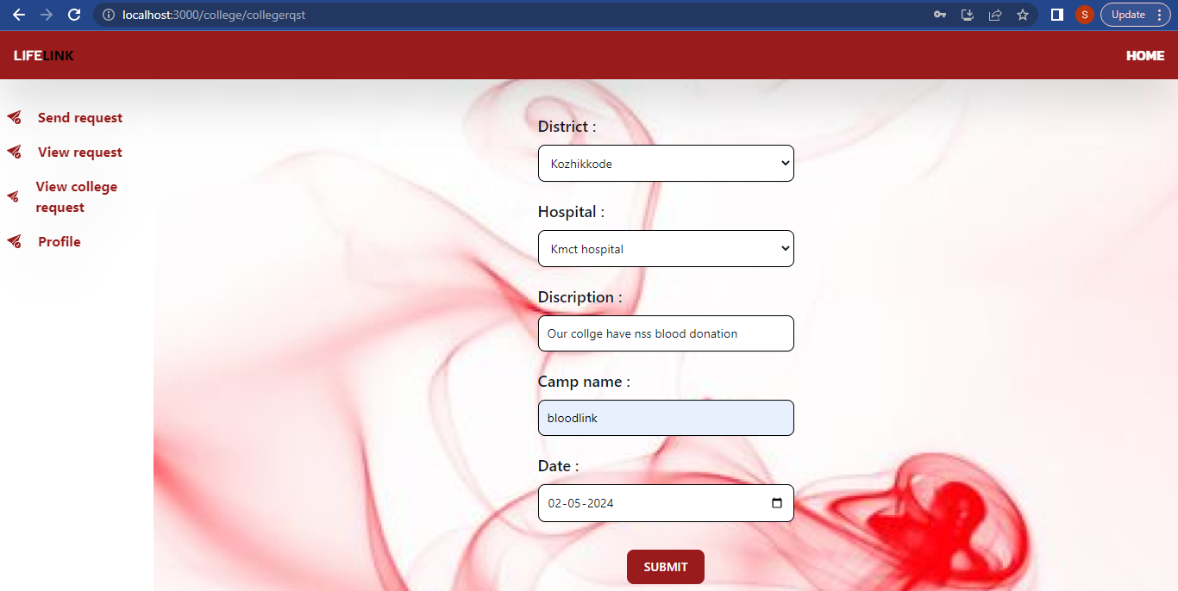

**College view hospital request**

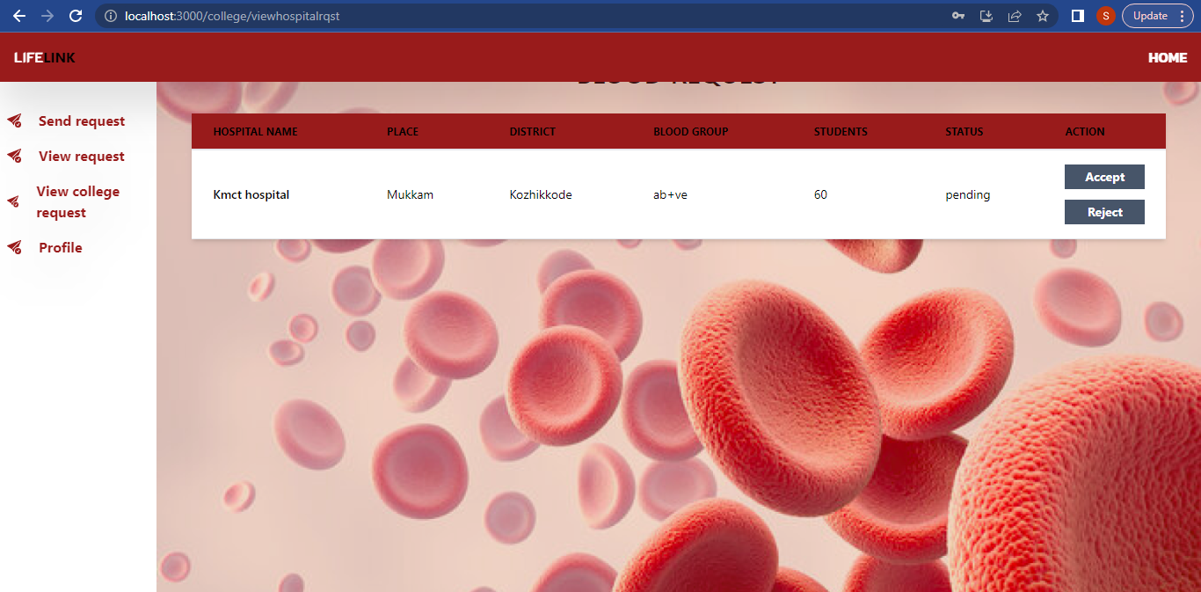

**College update profile**

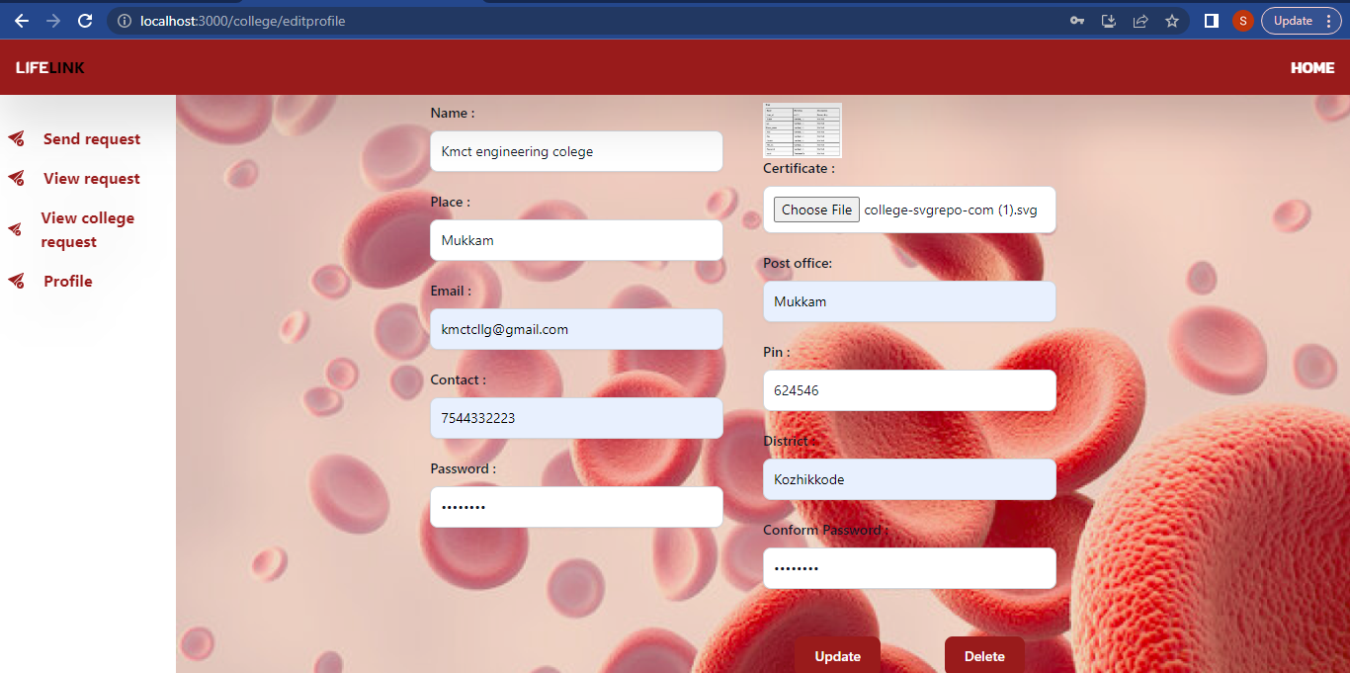

**Organ donor home page**

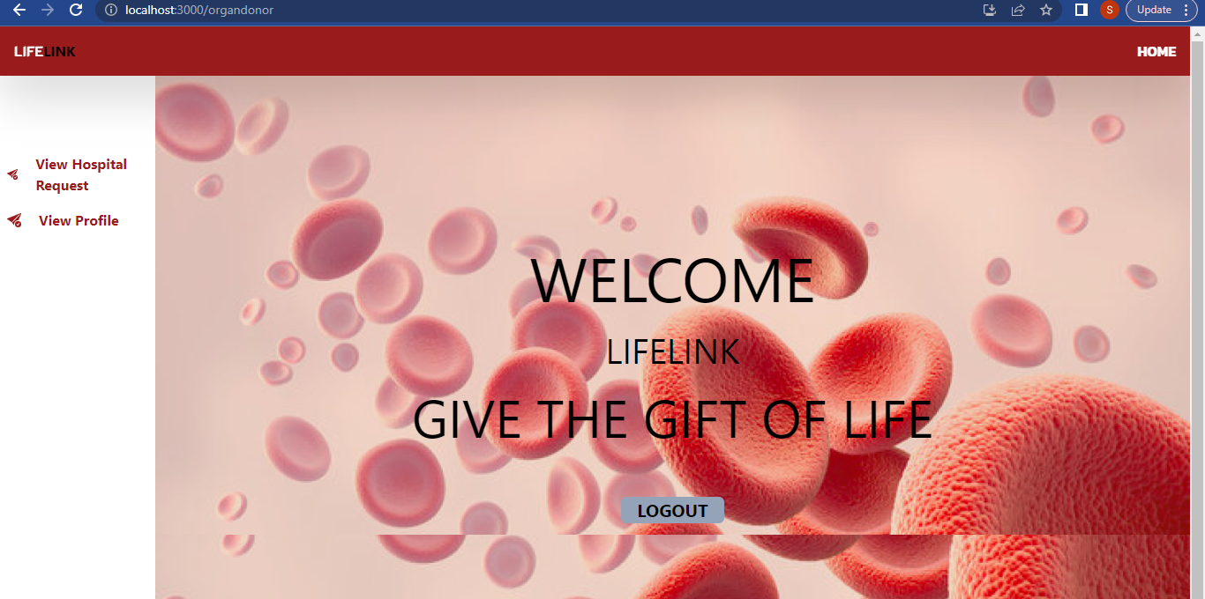

**View and accept hospital request**

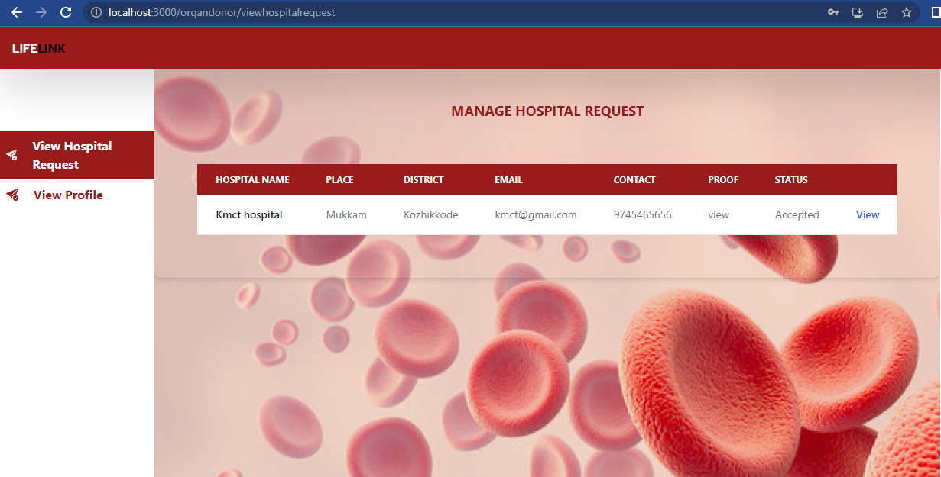

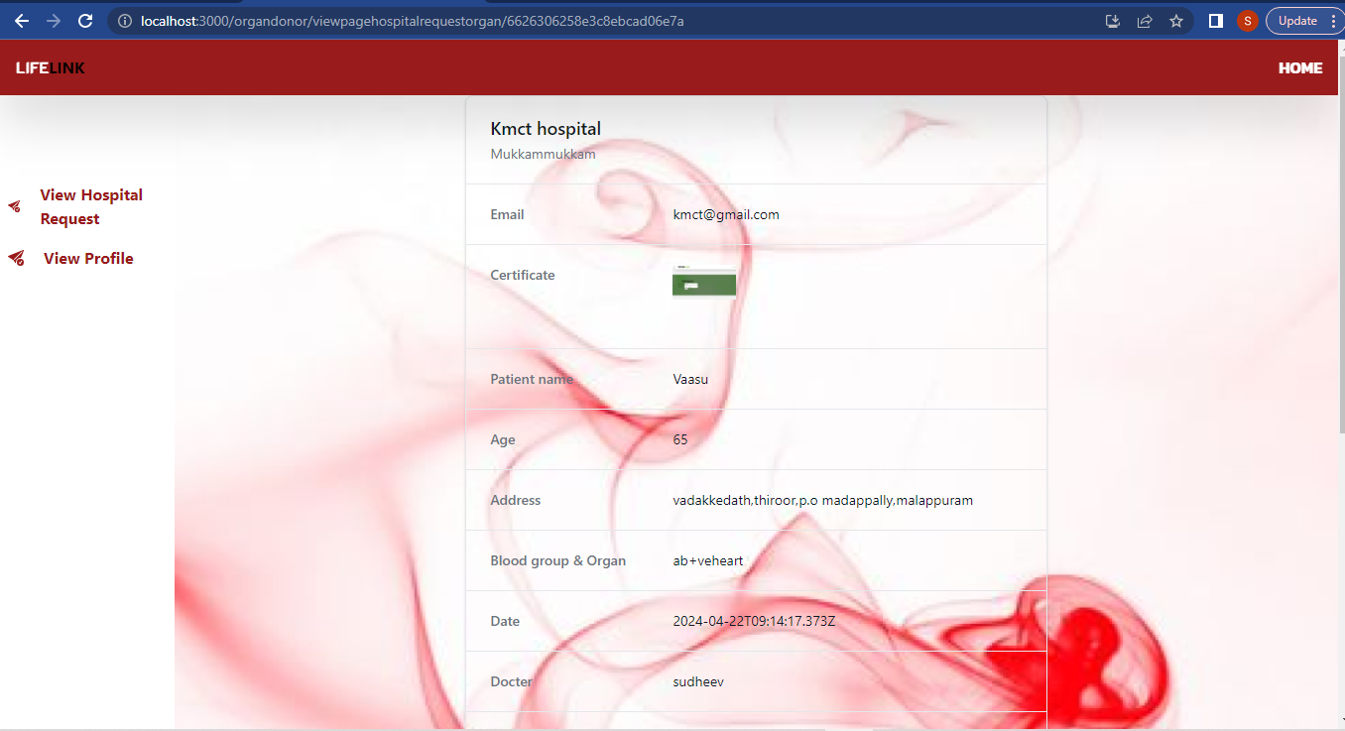

**Organ donor update profile**

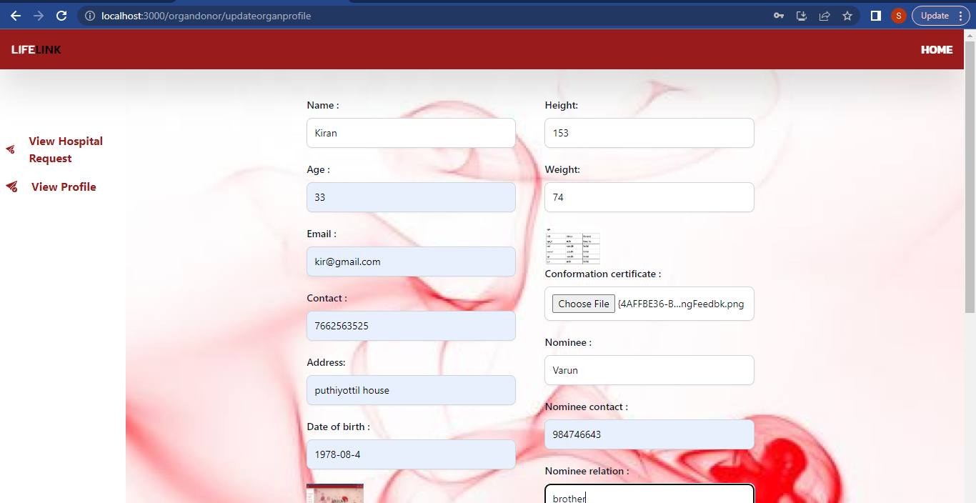

**User home page**

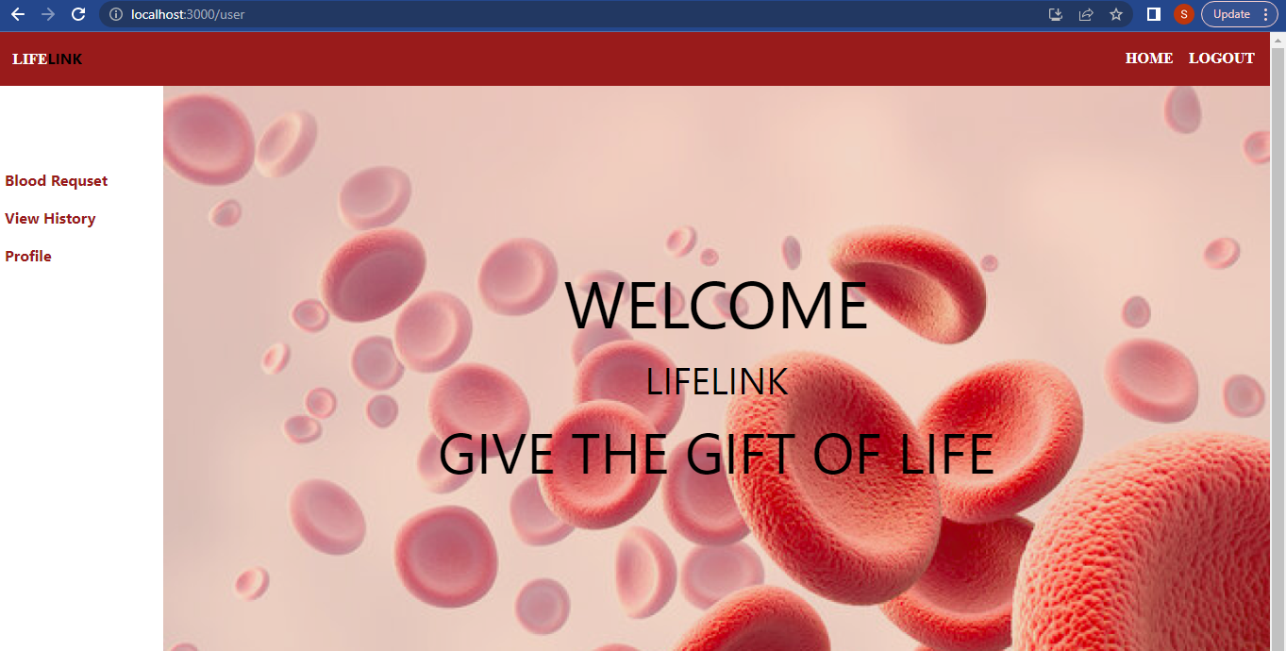

**User send request**

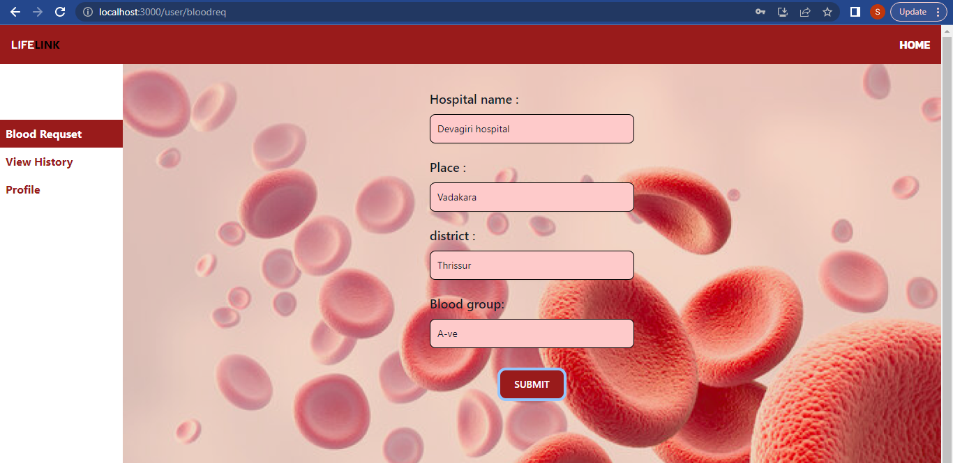

**User view history**

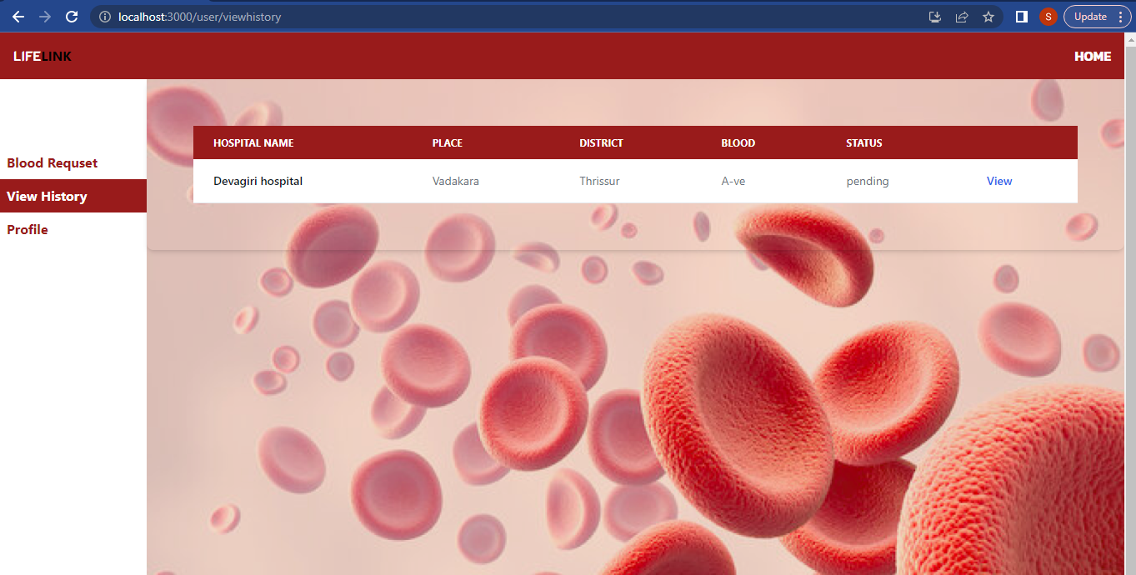

**User update profile**

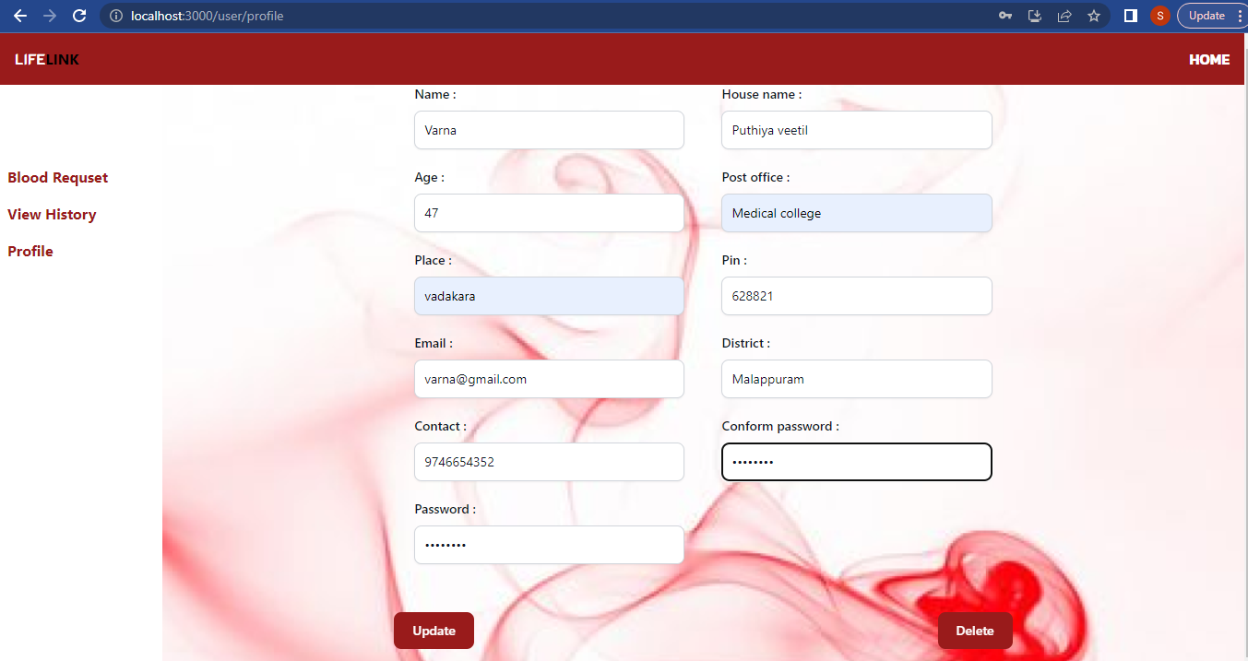

## BIBLIOGRAPHY

### 7.BIBLIOGRAPHY

#### Websites

1. [*https://www.programiz.com/javascript/spread-operator*](https://www.programiz.com/javascript/spread-operator)
2. [*https://developer.mozilla.org*](https://developer.mozilla.org)*/en-US/docs/Web/HTML*
3. [*https://www.geeksforgeeks.org/express-js-req-param-function/?ref=ml_lbp*](https://www.geeksforgeeks.org/express-js-req-param-function/?ref=ml_lbp)
4. [*https://nodejs.org/en/learn/getting-started/nodejs-with-typescript*](https://nodejs.org/en/learn/getting-started/nodejs-with-typescript)

[5] [*https://mongodb.github.io/node-mongodb-native/3.6/api/Collection.html#find*](https://mongodb.github.io/node-mongodb-native/3.6/api/Collection.html#find)

#### Books

[1] *Thomas A Powell, Fritz Schneider, “JavaScript: The Complete*

*Reference”, 3rd Edition,*  *Tata McGraw Hill*

[2] *Pro MERN Stack: Full Stack Web App Development with Mongo, Express, React, and Node" by Vasan Subramanian*

[3] *Code complete: a practical handbook of software construction by Steve McConnell, Microsoft Press,2nd Edition(2004).*

[4] *Full Stack Development with JHipster: Build scalable and maintainable web applications using the MERN stack" by Deepu K Sasidharan and Sendil Kumar N*

[5] *Full Stack JavaScript: Learn Backbone.js, Node.js, and MongoDB" by Azat Mardan*